**EVALUATING THE ALLOWABLE STORAGE TIME OF SELECTED SOYBEAN VARIETIES WITH THREE RELATIVE MATURITY GROUPS**

Ibukunoluwa Ajayi-Banji, Kenneth Hellevang, and Ewumbua Monono

Department of Agricultural and Biosystems Engineering, North Dakota State University, Fargo, North Dakota.

**ABSTRACT**

The advent of newer soybean varieties with different genomic configurations over the past decades has necessitated the need to update information on the allowable storage time used by producers and processors. Therefore, the objective of the study was to evaluate the effect of typical storage temperatures (-15 °C, 4 °C and 22.5 °C) and soybean moisture contents (11%, 13%, 15%, and 17% wet basis) on the allowable storage time of three soybean varieties (EL30-33, XF31-32N and P23A40E) with relative maturity (RM) groups (0.3, 1.3 and 2.3) for 9 months. Quality parameters used to determine the allowable storage time were germination, fungal (mold and yeast count) development, and oil quality (peroxide, free fatty acid (FFA), and P-anisidine value). The allowable storage time (AST) of 11% moisture content seeds was 270 days except for variety P23A40E at 240 days. The 13% moisture content seeds of P23A40E showed quicker deterioration at 22.5 °C with an AST of 60 days compared to the other varieties with about 150 and 180 days. At lower storage temperatures of -15 °C and 4 °C, for all varieties, AST was 270 days. Seeds at 11% moisture content had stable mold counts for all varieties till the end of the storage period.

Mold counts for 13% moisture content seeds of P23A40E were below the defined AST limit at the end of week 36, but the mold counts for seed variety EL30-33 increased between weeks 16 and 24, and maximum counts were recorded for XF31-32N by the end of week 36. The mold count increased significantly for the 15% and 17% moisture seeds under the same temperature by the end of week 2 and 4 respectively.

Free fatty acid content increased significantly by weeks 8, 12, and 16 exceeding acceptable limits of 0.75% for high moisture (15% and 17%) seeds at 22.5 °C. There was little difference in the FFA, peroxide, and P-Anisidine value of seeds stored at lower moisture contents (11% and 13%) at all storage temperatures.

These results suggest that seed variety and maturity group affect storability, especially at warm temperatures. This information will be used to update existing allowable storage timetables for soybean to enable producers to make informed management decisions.

**1.1. Introduction**

According to the USDA Economic Research Service, the U.S. soybean production is expected to be at 4.8 billion bushels for the marketing year 2024/2025 which is 8 % higher than year 2023/2024 (USDA-ERS, 2024). In another National Agricultural Statistics Service (NASS) 2024 report, soybeans stored in North Dakota totaled 34.9 million bushels, up 80% from the previous year. With this increase in on-farm and off-farm stocks in northern regions of the U.S., maintaining the quality of soybean seeds in storage is critical to minimizing economic losses for producers and processors. There exists a wide range of soybean varieties planted across the United States. The development and choice of varieties planted are dependent on many factors. These factors range from end-use either for food, feed, or industrial purposes. Others include disease-resistant varieties.

Soybean storability is largely dependent on seed moisture content and temperature of storage. Prior research studies on soybean storage considered the effect of respiration rates and dry matter loss on the quality of soybeans stored at different moisture contents and temperature conditions. Some recommendations used the information from safe storage time from cereal grains (corn) to determine the allowable storage time (AST) of mature soybeans based on the starch portion of the soybean. Typical soybean moisture contents and temperatures of storage used in these past studies range from (11% - 20%) and (4 °C - 35 °C) respectively.

The research findings from these studies were used to develop improved allowable storage timetables for mature soybeans. AST tables have been used in past decades by farmers and storage managers. Whilst this information has been helpful to farmers over time, it has become imperative to review and update the existing AST tables for the following reasons.

1. The advent of newer soybean varieties with different genomic configurations for different end-uses requires research on determining the influence of variety on storage time.
2. The effect of different soybean relative maturity groups based on planting locations in the upper midwest region on the allowable storage time.
3. Comparison of existing AST tables for soybeans based on dry matter loss of cereal grains (corn) show differing values.
4. The current increase in the soybean crushing plants in the region needing to operate all year round during warmer months calls for updated information on storage periods and conditions to maintain quality.
5. The use of a combination of quality parameters of germination, mold development, and oil quality to compare with AST values from other existing tables.

Preliminary research from our study in 2022 considered the effect of different quality parameters to determine the allowable storage time of two soybean varieties planted in North Dakota. Germination, mold development, and oil quality were used to determine the allowable storage time. The results from the study found values differing from existing tables. To further develop confidence in the recommendation for farmers, the research was continued in 2023 and was expanded to accommodate the effect of soybean relative maturity groups in the region in addition to the different varieties used in the study.

The common storage temperatures of soybeans in the Northern region are at (-15 °C, 4 °C, and 22.5 °C) to mimic a full weather cycle with fall, winter, spring, and summer. Typical harvest moisture content is at 13% to minimize shatter losses. In seasons of a lot of rainfall, and cool conditions soybeans are harvested at higher moisture contents of up to 17% and dried to prevent field losses. Therefore, in this study, three soybean varieties P23A40E, EL30-33, and XF31-32N with relative maturity groups of 2.3, 0.3, and 1.3, freshly harvested and bagged were procured from two commercial seed companies (Pioneer and Proseed). The study evaluated the effect of typical storage temperatures (-15 °C, 4 °C, and 22.5 °C) and soybean moisture contents (11%, 13%, 15%, and 17% wet basis) for 270 days. Quality parameters analyzed to determine the allowable storage time were germination, fungal (mold) development, and oil quality (peroxide, free fatty acid, and P-anisidine value). An allowable storage timetable was developed based on each quality parameter analyzed and then a general AST chart using minimum values from each quality parameter.

**2.0. Materials and Methods**

2.1. Soybean Seeds Procurement and Conditioning

Three soybean varieties P23A40E, EL30-33, and XF31-32N of relative maturity groups (MG) 2.3, 0.3, and 1.3 were used in the study. Relative maturity groups 2.3 and 0.3 were grown in Minnesota while 1.3 was from North Dakota. Relative Maturity group 0 is more adapted to North Dakota and Northern Minnesota. Relative maturity groups 1 and 2 are more adapted to Michigan, Nebraska, and Northern Iowa. Relative MG 2.3 was purchased from Pioneer Seed Company, and MGs 0.3 and 1.3 were purchased from a commercial seed supplier (Proseed) in North Dakota. The soybeans were received in approximately 50 lbs paper bags at initial moisture contents of 8.9%, 10.5%, and 9.2% respectively, and stored in a refrigerator at 4 °C to 5 °C temperature. The cleaned seeds for each variety were divided into four portions in which each portion was conditioned to moisture contents (MCs) of 11%, 13%, 15%, and 17%. The amount of water needed to achieve the target moisture contents was calculated using the equation 1.1 below:

$Mw=Mc \left(\frac{Wf-Wc}{100\%-Wf }\right)$ 1.1

Where: Mw = Mass of water added (g)

Mc = Initial weight of cleaned seeds (g)

Wc = Initial moisture content of cleaned seeds (%)

Wf = Final desired moisture content (%)

The seeds were placed in a tote pail on a weighing balance and the calculated amount of distilled water was sprayed on the seeds. The soybean seeds were thoroughly mixed with the aid of a portable electric cement mixer (2 cubic ft. Poly drum, Klutch, Northern Tool Equipments ND, USA) and temporarily stored in the refrigerator for 24 hours to allow for moisture equilibration before storage set-up. The moisture content of the seeds was verified using the GAC 2100 capacitance-based moisture analyzer (Dickey John, USA) and again through the oven drying method at 103 ℃ for 72 h.

2.2. Storage Setup

After conditioning the soybeans to the target moisture levels of (11%, 13%, 15%, and 17%), 600g of the soybeans were weighed and immediately put in individual clearly labeled airtight “plymor” heavy-duty plastic recloseable (0.004 thick) LDPE polyethylene FDA compliant zipper bags. The labeled bags were then placed in sealed 103 L- tough storage tote pails at the three separate storage temperatures of -15 ℃ (walk-in freezer), 4 ℃ (refrigerated cold room), and 22.5 ℃ (temperature-controlled room). The samples were stored for 9 months and analyzed after 0, 1, 2, 3, 4, 6, and 9 months of storage.

Hobo data loggers were inserted in the storage tote pails in the three separate environments to monitor the temperature and relative humidity of the container in which the seeds were stored to ensure the storage environment temperatures were maintained. Soybean samples pulled out on the day of storage set-up were referred to as week-0 samples during the analysis. Hobo data loggers were removed from storage totes after the experiment and data was downloaded using the Hoboware desktop app. The output data was transferred to Excel, and the values were averaged to obtain the temperature and relative humidity profile over 270 days.

* 1. **Quality Analysis of Stored Seeds**

***2.3.1. Seed germination test***

The germination test for stored seeds was carried out every month according to the (AOSA, 2009) methods. Germination test was conducted in quadruplicates, by placing 25 seeds between two brown wet germination papers, rolled, and stored in an airtight plastic pail at room temperature to prevent moisture loss. The rolled wet papers were then placed in a sealed plastic pail at room temperature (23 ± 2) ℃ for seven days. Afterward, germination counts were obtained, and percentage germination was calculated based on the average counts from the four replicates per stored sample. Germination was determined based on the number of seeds that produced normal seedlings.

2.3.2. Enumeration of fungal (Mold and Yeast) counts

The stored seeds were analyzed for mold and yeast development every week for the first twenty-eight weeks and then at week 36. The soybean seed samples from each storage bag were collected in a sterile stomacher bag and plated in duplicates onto Dichloran-Glycerol DG-18 Agar base (Oxiod Ltd, Basingstoke, Hampshire England) to determine yeast and mold counts using the spread-plate method according to FDA’s Bacteriological analytical manual (Tournas et al., 2001). A DG -18 agar was prepared by suspending 15.75 g in 500 mL of distilled water. 110 g of glycerol (analytical reagent grade) was added to the water solution along with 50 mg of chloramphenicol rehydrated in 2.5 ml of ethanol. This agar solution was sterilized in an autoclave at 121 °C for 30 mins. The solution was cooled to 50 °C, mixed, and poured into sterile Petri dishes. Soybean samples (30 g) were homogenized with 150 mL of 0.1% peptone water for 60 seconds using a Stomacher Circulator Lab Blender set at 230 revolutions/min (rpm). Successive dilutions were made by mixing 1 mL of the solution with 9 ml of the 0.1% peptone water in a sterile centrifuge tube and repeating the dilution until 10 -5 dilution was achieved. After spread plating in Petri dishes, the DG-18 agar plates were incubated in the dark at 25ºC for 7 days. Every colony on the DG-18 agar plate was counted. Yeast are not bacteria but could look like bacterial colonies at the visual level. This was used to differentiate yeast from mold. Therefore bacterial-like colonies were counted as yeast colonies while the colored fluffy colorful and moldy colonies were counted as mold colonies. Mold counts were recorded in an average number of mold and log transformed (CFU/g) using the appropriate dilution factor. Plates from all dilutions with no colonies reported for mold and yeast counts were recorded as less than one time the dilution was used.

* + 1. **Oil Extraction and Quality Analysis**

An oilseed screw press (Komet, Germany) was used for expelling oil from the soybean seed samples at a temperature of 60 ± 2 ºC. The crude oil was then centrifuged using a Jouan CR 412 centrifuge at room temperature for 7 min and a speed of 4,500 rpm. After centrifugation, the clear supernatant was poured into a 50 mL black plastic vial. Oil quality (Peroxide, FFA, and P-Anisidine) was determined using a CDR Food Lab junior laboratory instrument from (Crystal Filtration, Michigan, USA).

* 1. **Development of Allowable Storage Time (AST) Chart**

The data for germination, mold, and oil quality were compiled and used to develop an approximate allowable storage time chart for soybeans. The minimum germination percentage in determining AST in this study was 90%. However, in the case where each replicate measurement of 25 seeds per sample had 90% germination or above, but with the presence of abnormal healthy seedlings with secondary infections, stunted growth, and loss of vigor, the germinability was determined based on the number of healthy seedlings. For mold counts, the time at which there was mold infestation with a considerable increase in initial log counts was used as the baseline for allowable storage time. Oil quality values (peroxide and FFA) above the recommended limits of 5 meq kg-1 and 0.75% respectively, were used as the baseline for the oil quality allowable storage time chart (Alimentarius, 1999).

* 1. Statistical Analysis

A multilevel factorial experiment design was developed in a 3 x 4 x 3 x 7 scheme: three relative maturity groups, four moisture contents, three storage temperatures, and eight storage times for the main experiment. There were three replicates (i.e., three bags containing 600 g of soybean seeds for each treatment). The data were subjected to analysis of variance using Minitab software 2021 (version 20.4.0.0) and separate analyses were carried out for each, germination, biological (fungal), and oil quality measurement. All factor types were fixed. A value of p ≤ 0.05 was used to indicate significant differences among the main effects. Tukey method was used to compare the differences between the main effect means and interaction using the least square determination (LSD) method. Pearson correlation test was used to determine if there was a relationship between germination and fungal (mold and yeast counts) and oil quality parameters. The analysis did not find a correlation between factors.

**3.0. Results and Discussion**

***3.1.1* Seed Germination**

Healthy seeds are often preserved by farmers and seed agencies for the next planting season or are used for food-grade soybeans. Therefore, it is important to determine the germination potential of stored seeds. Germination was influenced by the moisture content of seeds, the storage period, and storage temperature. Varietal differences affected germination percentage during storage. This was prominent in seeds stored at 22.5 °C. For all three varieties stored at 11% moisture content, germination percentage remained > 98% over 36 weeks of storage except for soybean variety P23A40E(2.3RM) with < 90% germination after week 32. A germination decrease (< 90%) was observed rapidly in variety P23A40E at 13% moisture content immediately after week 8. The germination percentage of the other two varieties (EL30-33 and XF31-32N) was maintained at > 90% until week 24 and week 16 respectively. At 15% moisture content, the germination percentage for all varieties was > 90% until the end of week 8, except for variety XF31-32N with germination percentage below 90% after the end of week 4. The germination percentage of all three varieties stored at 17% dropped to below < 60% at the end of week 4 (Fig 1 and 2). At other storage temperatures of -15 °C and 4 °C, the germination percentage was > 98% all through the storage period across all moisture contents for all varieties. Though high germination percentages were maintained at these temperatures, it is not adequate to determine seed quality. This is because at high moistures of 15% and 17% germinated seedlings were observed to be stunted, with low vigor and specks of secondary infections as storage time progressed. Tables 1 to 4 show the estimated and final allowable storage time based on 90% germinability.

**P23A40E(2.3RM) EL30-33(0.3RM)**

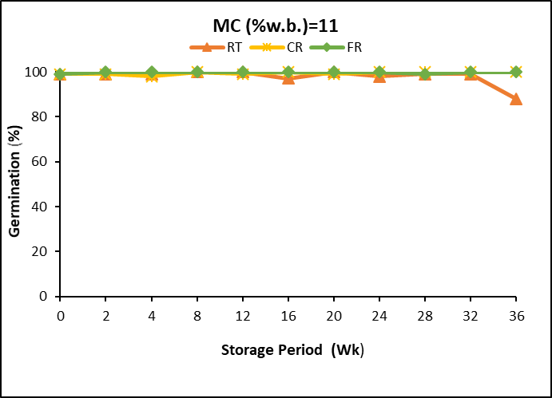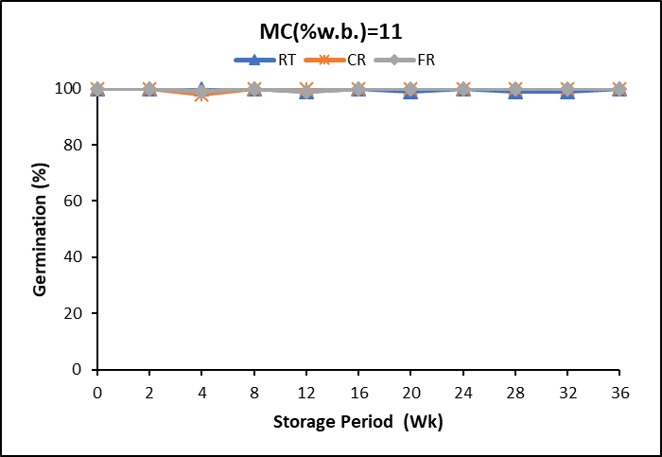

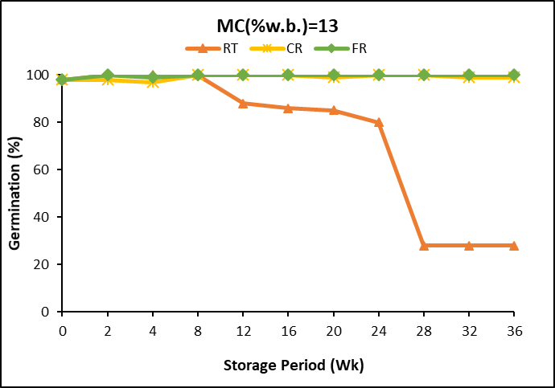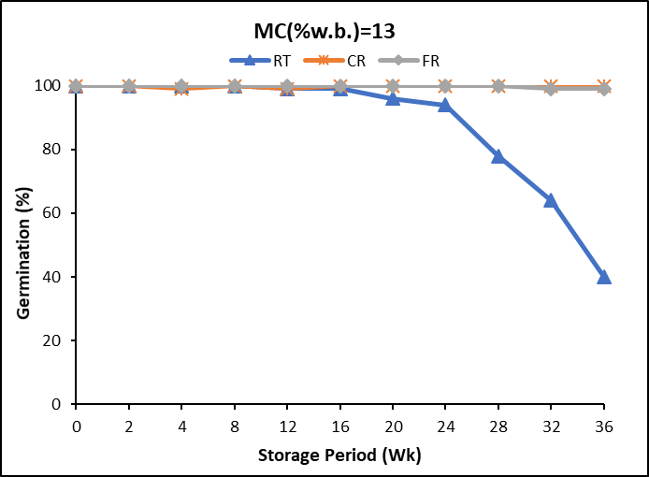

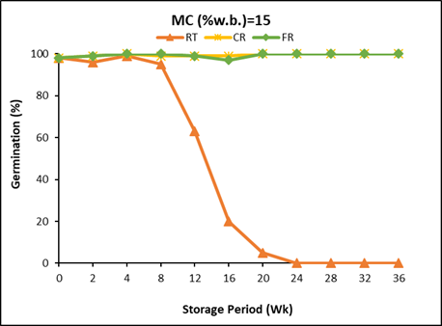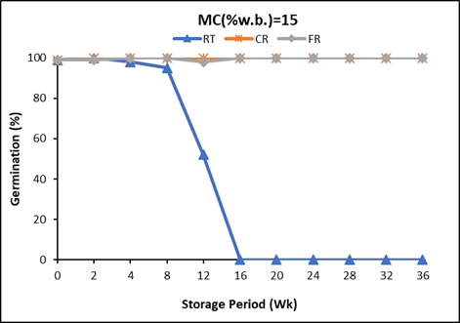

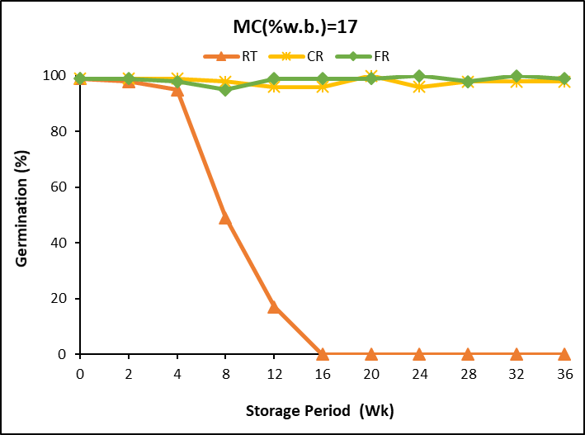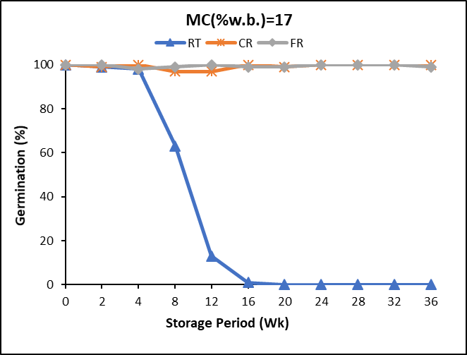

Figure 1. Germination percentage of soybean seeds stored at three storage temperatures of (-15 °C, 4 °C, and 22.5 °C) for variety P23A40E and EL30-33.

**XF31-32N (1.3RM)**

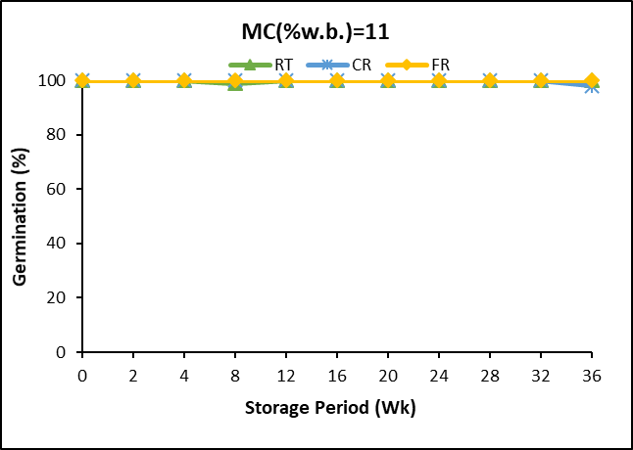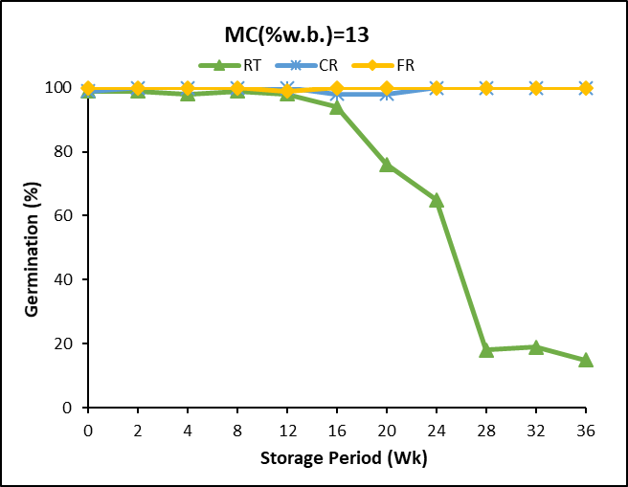

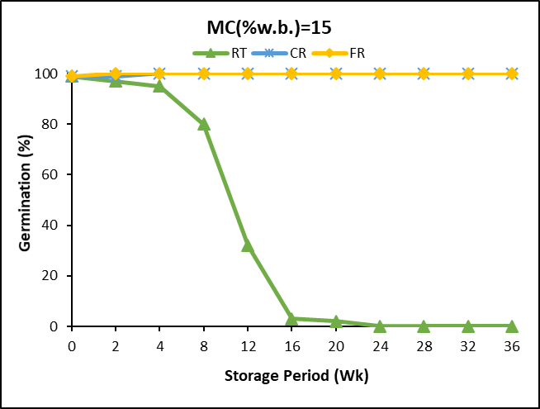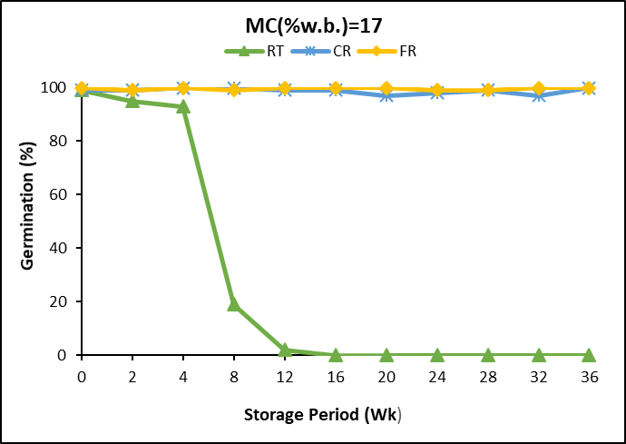

Figure 2. Germination percentage of soybean seeds stored at three storage temperatures of (-15 °C, 4 °C, and 22.5 °C) for variety P23A40E and EL30-33.

Table 1. “Estimated” Soybeans Allowable Storage Time (Days) based on 90% Germinability.

|  |  |  |  |
| --- | --- | --- | --- |
|  | **EL30-33 (0.3RM)** | | |
|  | Grain Temperature °C (° F) | | |
| **Moisture content (%)** | **-15 (4)** | **4 (40)** | **22.5 (72)** |
|  | **Approximate Allowable Storage Time (Days)** | | |
| 11 | 270 | 270 | 270 |
| 13 | 270 | 270 | 180 |
| 15 | 270 | 270 | 61 |
| 17 | 270 | 270 | 31 |

Table 2. “Estimated” Soybeans Allowable Storage Time (Days) based on 90% Germinability

|  |  |  |  |
| --- | --- | --- | --- |
|  | **XF31-32N (1.3RM)** | | |
|  | Grain Temperature °C (° F) | | |
| **Moisture content (%)** | **-15 (4)** | **4 (40)** | **22.5 (72)** |
|  | **Approximate Allowable Storage Time (Days)** | | |
| 11 | 270 | 270 | 270 |
| 13 | 270 | 270 | 150 |
| 15 | 270 | 270 | 30 |
| 17 | 270 | 270 | 30 |

Table 3. “Estimated” Soybeans Allowable Storage Time (Days) based on 90% Germinability

|  |  |  |  |
| --- | --- | --- | --- |
|  | **P23A40E (2.3RM)** | | |
|  | Grain Temperature °C (° F) | | |
| **Moisture content (%)** | **-15 (4)** | **4 (40)** | **22.5 (72)** |
|  | **Approximate Allowable Storage Time (Days)** | | |
| 11 | 270 | 270 | 240 |
| 13 | 270 | 270 | 60 |
| 15 | 270 | 270 | 60 |
| 17 | 270 | 270 | 30 |

Table 4.  **Composite “Estimated” Soybeans Allowable Storage Time based on 90% Germinability**

|  |  |  |  |
| --- | --- | --- | --- |
|  | **All three varieties** | | |
|  | Grain Temperature °C (° F) | | |
| **Moisture content (%)** | **-15 (4)** | **4 (40)** | **22.5 (72)** |
|  | **Approximate Allowable Storage Time (Days)** | | |
| 11 | 270 | 270 | 240 |
| 13 | 270 | 270 | 60 |
| 15 | 270 | 270 | 30 |
| 17 | 270 | 270 | 30 |

***3.1.2.*** **Mold Counts**

The presence of mold on stored grain shows grain quality deterioration. A visible increase in the mold was observed on the 17% moisture content seeds for all varieties at week 4. A significant increase in mold counts was observed after week 2 for all varieties. Between week 0 and week 4, initial log counts increased for each of the varieties. Initial log counts increased by 38% (3.23 to 4.46) for varieties P23A40E, by 121% (2.06 to 4.57) for EL30-33, and by 47% (3.61 to 5.29) for XF31-32N. Since mold development was observed after the second week in 15 % and 17% seeds, an increase in the log count was used in addition to determining AST based on fungal count (mold and yeast). For 15% moisture content seeds, after week 8, mold counts increased to over 4.22CFU/g for variety P23A40E, 5.04CFU/g for EL30-33, and 5.21CFU/g XF31-32N. Low to medium visible mold was observed on the surface of the seeds before the fungal analysis showing some level of seed spoilage. At the end of week 36, log counts for 13% moisture content seeds of P23A40E were below the defined AST limit. Mold counts for seed variety EL30-33 increased from 2.70 to 4.81 CFU/g between weeks 16 and 24. Maximum log counts of 4.90CFU/g were recorded for XF31-32N by the end of week 36. Seeds at 11% moisture content had stable log counts for all varieties till the end of the storage period (Fig 3 and 4). As the storage period progressed mold counts for seeds stored at -15 °C were relatively stable till the end of week 36. At 4 °C, mold counts for high moisture seeds (15% and 17%) of variety P23A40E had increased to above 4.46CFU/g by the end of week 24. Varietal differences affected the mold counts at 4 °C and at 22.5 °C generally. Tables 5 to 8 show the estimated allowable storage time (AST) and final estimated AST based on mold counts.

**P23A40E – 2.3RM EL30-33 – 0.3RM**

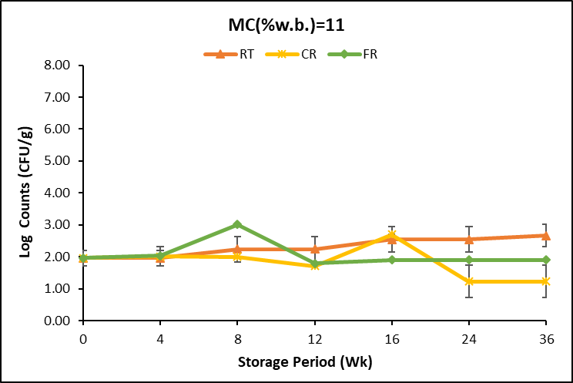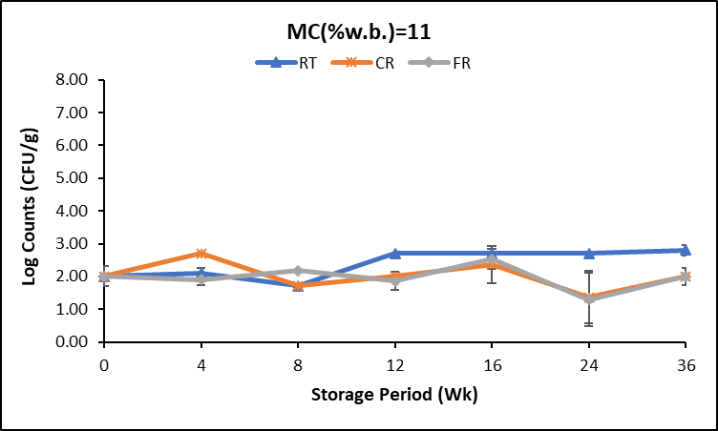

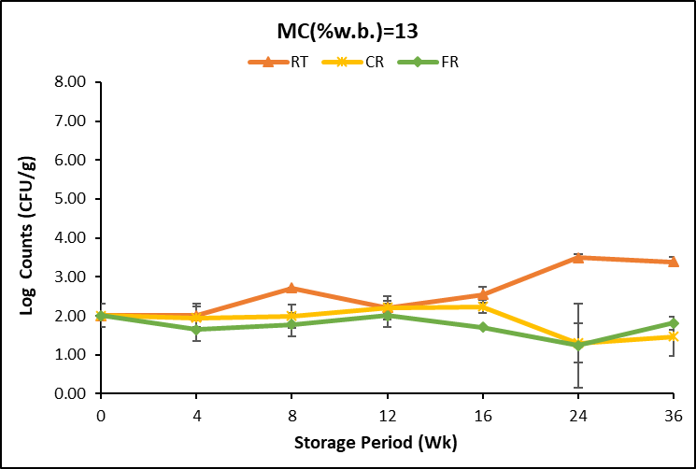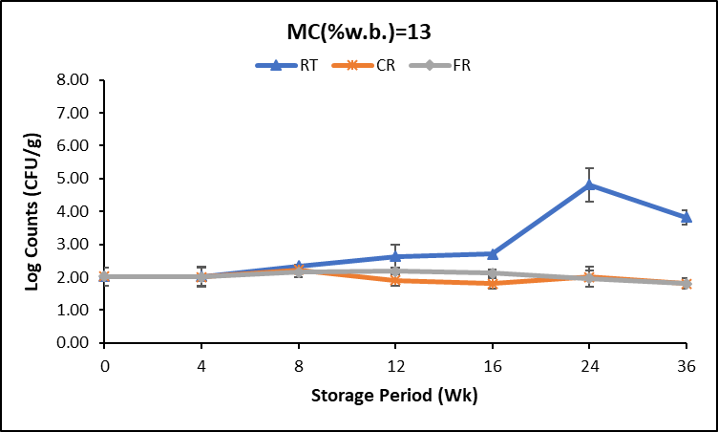

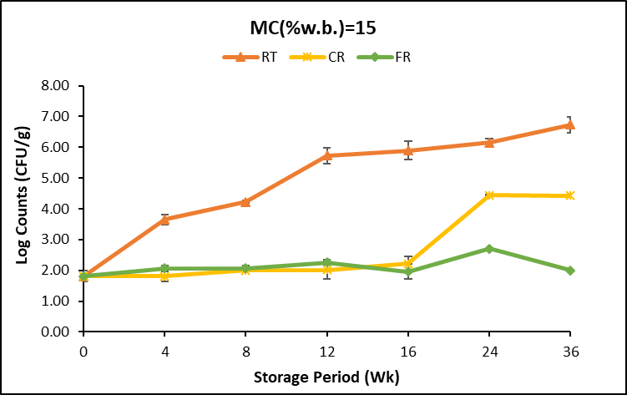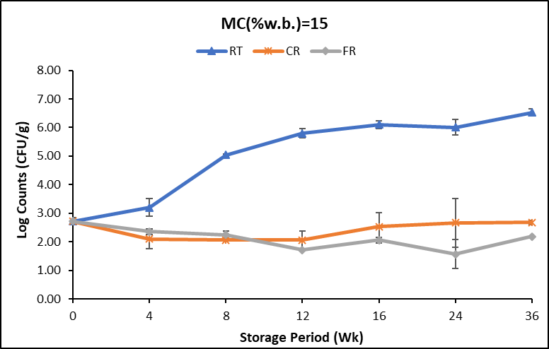

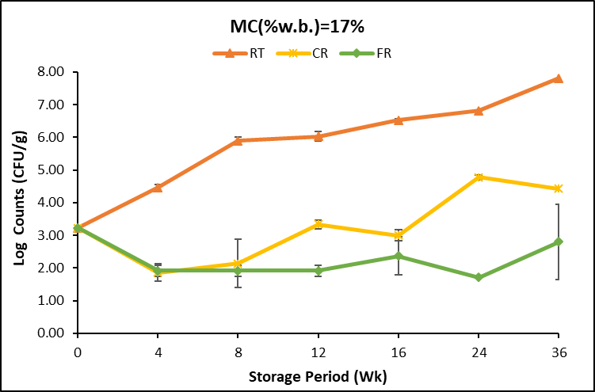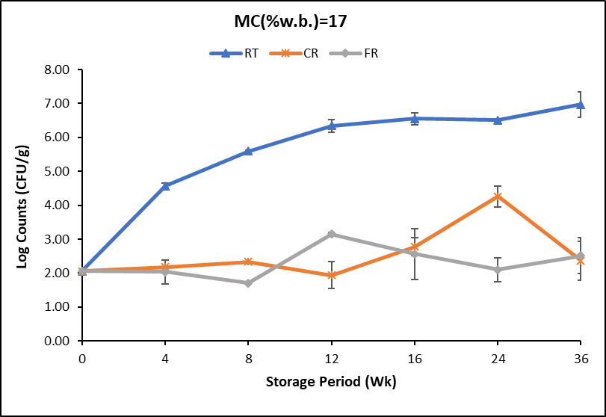

Figure 3. Mold counts of soybean seeds at three storage temperatures for P23A40E and EL30-33.

**XF31-32N- 1.3RM**

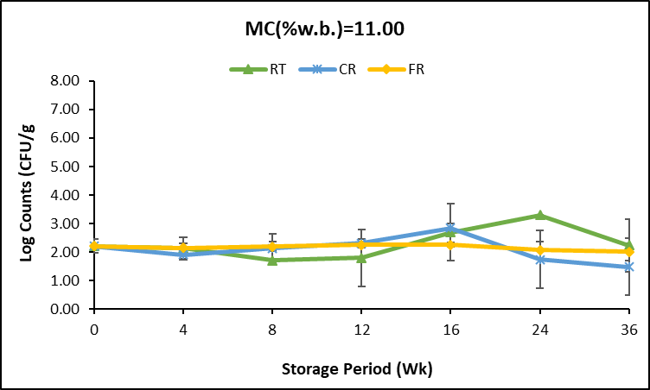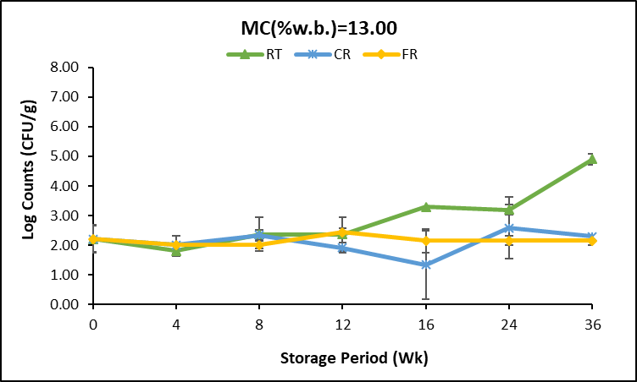

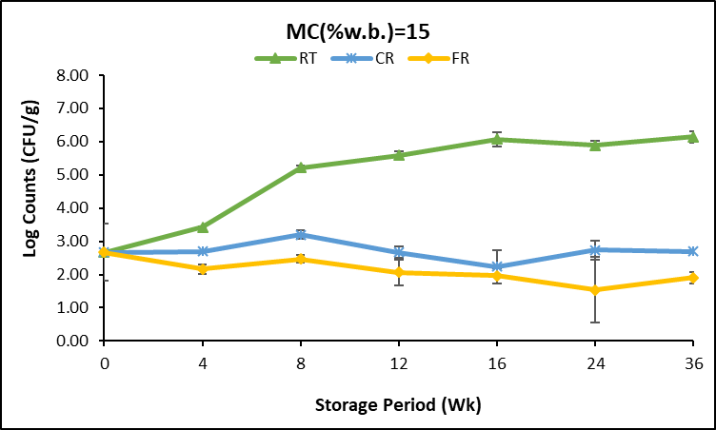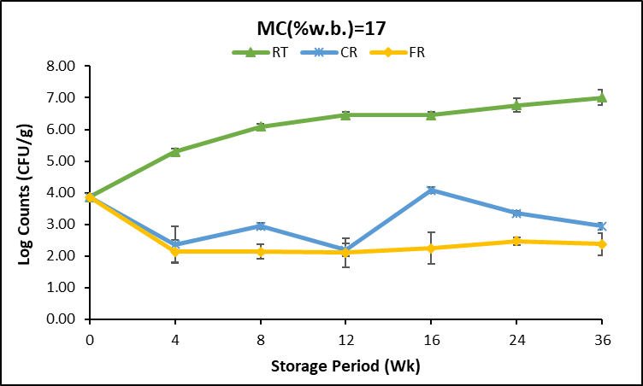

Figure 4. Mold counts of soybean seeds at three storage temperatures for XF31-32N

Table 5.“Estimated” Soybeans Allowable Storage Time (Days) based on Fungal (Mold and Yeast) Count for EL30-33 (0.3RM)

|  |  |  |  |
| --- | --- | --- | --- |
|  | **EL30-33 (0.3RM)** | | |
|  | Grain Temperature °C (° F) | | |
| **Moisture content (%)** | **-15 (4)** | **4 (40)** | **22.5 (72)** |
|  | **Approximate Allowable Storage Time (Days)** | | |
| 11 | 270 | 270 | 270 |
| 13 | 270 | 270 | 120 |
| 15 | 270 | 240 | 30 |
| 17 | 270 | 90 | 14 |

Table 6. “Estimated” Soybeans Allowable Storage Time (Days) based on Fungal (Mold and Yeast) Count for XF31-32N (1.3RM)

|  |  |  |  |
| --- | --- | --- | --- |
|  | **XF31-32N (1.3RM)** | | |
|  | Grain Temperature °C (° F) | | |
| **Moisture content (%)** | **-15 (4)** | **4 (40)** | **22 (72)** |
|  | **Approximate Allowable Storage Time (Days)** | | |
| 11 | 270 | 270 | 270 |
| 13 | 270 | 240 | 120 |
| 15 | 270 | 270 | 30 |
| 17 | 270 | 120 | 14 |

Table 7. “Estimated” Soybeans Allowable Storage Time (Days) based on Fungal (Mold and Yeast) Count for P23A40E (2.3RM)

|  |  |  |  |
| --- | --- | --- | --- |
|  | **P23A40E (2.3RM)** | | |
|  | Grain Temperature °C (° F) | | |
| **Moisture content (%)** | **-15 (4)** | **4 (40)** | **22.5 (72)** |
|  | **Approximate Allowable Storage Time (Days)** | | |
| 11 | 270 | 270 | 270 |
| 13 | 270 | 270 | 120 |
| 15 | 270 | 120 | 42 |
| 17 | 270 | 60 | 30 |

The lowest AST number from the estimated table for each variety for each quality parameter analyzed was used to develop the estimated allowable storage timetable based on fungal infestation.

Table 8. “Estimated” Soybeans Allowable Storage Time based on 90% Fungal (Mold and Yeast) Count

|  |  |  |  |
| --- | --- | --- | --- |
|  | **All three varieties** | | |
|  | Grain Temperature °C (° F) | | |
| **Moisture content (%)** | **-15 (4)** | **4 (40)** | **22.5 (72)** |
|  | **Approximate Allowable Storage Time (Days)** | | |
| 11 | 270 | 270 | 270 |
| 13 | 270 | 240 | 120 |
| 15 | 270 | 120 | 30 |
| 17 | 270 | 60 | 14 |

**3.1.3. Oil quality**

***3.1.3.1.*  Free Fatty Acids (FFA)**

The Free fatty acid content in the oil from 17% moisture content seeds at room temperature (22.5 °C) increased throughout storage for all the varieties. By the end of week 12, the recommended acceptable limit of 0.75% was exceeded for variety XF31-32N. Variety EL30-33 free fatty acid content was 2.10% by week 16 and by week 20 P23A40E variety was at 1.60% as shown in Fig 5 – Fig 7.

FFA contents for 15% moisture content soybeans also exceeded the acceptable limit by week 12 for variety XF31-32N, week 36 for EL30-33, and P23A40E by week 20 showing deterioration in the seed quality. The Free fatty acid contents of oil from stored seeds at 4 °C and -15 °C were very low and within the recommended limit all through the storage period. Based on FFA content, variation is observed based on the soybean variety. Table 9 shows the estimated allowable storage time based on Free fatty acid content in the oil.

Figure 5. Free fatty acid content of oil from stored soybeans at room temperature (22.5 °C) for soybean variety P23A40E

Figure 6. Free fatty acid content of oil from stored soybeans at room temperature (22.5 °C) for soybean variety EL30-33.

Figure 7. Free fatty acid content of oil from stored soybeans at room temperature (22.5 °C) for soybean variety XF31-32N

Table 9.“Estimated” Soybeans Allowable Storage Time (Days) based on Free Fatty Acid content

|  |  |  |  |
| --- | --- | --- | --- |
|  | **EL30-33(0.3RM), XF31-32N(1.3RM) and P23A40E(2.3RM)** | | |
|  | Grain Temperature °C (° F) | | |
| **Moisture content (%)** | **-15 (4)** | **4 (40)** | **22.5 (72)** |
|  | **Approximate Allowable Storage Time (Days)** | | |
| 11 | 270 | 270 | 270 |
| 13 | 270 | 270 | 270 |
| 15 | 270 | 270 | 240/90/150 |
| 17 | 270 | 270 | 90/61/120 |

***3.1.3.2.* Peroxide Value (PV)**

Peroxide values recorded were low throughout storage irrespective of the storage temperature. However, a slight increase in peroxide values was observed at week 16 for 17% moisture content seeds of varieties EL30-33 and XF31-32N as shown in Fig. 8. The values however were still within the low degree of oxidation which is between 1 to 5meq kg-1. All the values recorded were within the range of a low degree of oxidation for all the storage temperatures. The varietal difference did not affect the peroxide value throughout the storage period. Only data for PV values for storage at 22.5 °C were presented as storage for all varieties at -15 °C and 4 °C were very low.

Figure 8. Peroxide value of oil from stored soybeans at room temperature (22.5 °C)

***3.1.3.3.* P-Anisidine**

P-anisidine measures secondary oxidation products like aldehydes and ketones in oils. The information from the peroxide value content of an oil analyzed when used together with P-anisidine results provides profound information about the quality of the oil. The P-anisidine values of the 11 and 13% moisture content seeds stored were relatively stable throughout storage as shown in Fig 9. P-anisidine (p-Anv) recommended limit for good oil quality should be less than 6 while for fresh frying oil should be less than 4. For high moisture (17%) seeds for all varieties in storage, a slight increase in the p-Anv was observed for all varieties after week 16. The p-Anv contents were however below the recommended limits for the oil quality deterioration. The P-Anv value of oil from stored seeds at 4 °C and -15 °C were very low and within the recommended limit all through the storage period.

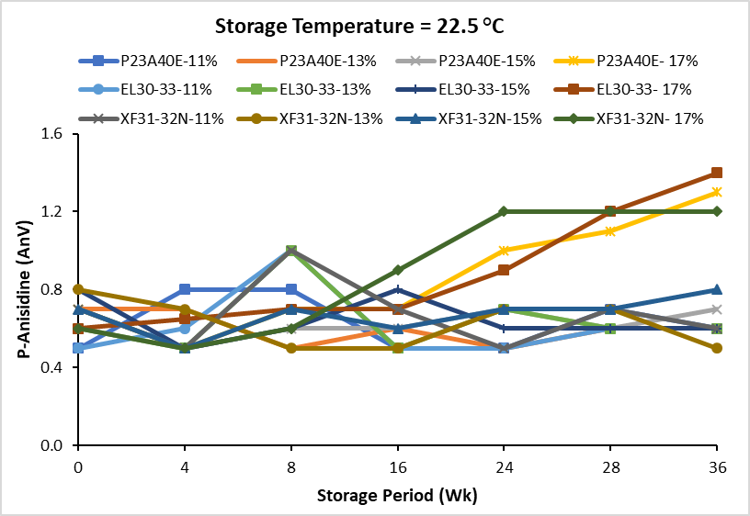

Figure 9. P-Anisidine value of oil from stored soybeans at room temperature (22.5 °C)

The Estimated Allowable Storage Time (AST) based on Peroxide value and P-Anisidine was not developed since the values were within recommended limits for all storage temperatures.

**4.0 Allowable Storage Time Based on this Study**

From this research, mold is the controlling factor for the quality parameters analyzed, therefore the final estimated AST table is shown below.

Table 10. “Estimated” Soybeans Allowable Storage Time based on USB Research

|  |  |  |  |
| --- | --- | --- | --- |
|  |  | | |
|  | Grain Temperature °C (° F) | | |
| **Moisture content (%)** | **-15 (4)** | **4 (40)** | **22.5 (72)** |
|  | **Approximate Allowable Storage Time (Days)** | | |
| 11 | 270 | 270 | 270 |
| 13 | 270 | 240 | 120 |
| 15 | 270 | 120 | 30 |
| 17 | 270 | 60 | 14 |

**5.0 Comparison of estimated USB AST table to NDSU and IOWA State University Tables**

A comparison of the existing tables (NDSU and ISU) with the estimated AST table from this research study funded by the United Soybean Board (USB) offers useful information on the AST of soybeans. At a storage temperature of **-**15°C, the current study result is similar to existing table recommendations (NDSU and ISU) as shown in Table 10. However, at 4 °C and 22.5 °C, differences in AST values are observed for 13%, 15%, and 17% moisture content soybeans. At 22.5 °C, 15% and 17% moisture content soybeans have longer allowable storage time, while 11% and 13% moisture content have shorter AST based on USB research than the existing recommendations (NDSU and ISU).

Table 11. “Estimated Soybeans Allowable Storage Time (Days) Comparison

|  |  |  |  |  |  |  |  |  |  |  |
| --- | --- | --- | --- | --- | --- | --- | --- | --- | --- | --- |
| Temperature | **-15** °C **(4** ° F**)** | | | **4** °C **(40** ° F**)** | | | **22.5** °C **(72** ° F**)** | | | |
| Existing/new AST tables | USB | NDSU | ISU | USB | NDSU | ISU | USB | NDSU | ISU |
| 11% | 270 | 300 | 300 | 270 | 300 | 300 | 240 | 200 | 300 |
| 13% | 270 | 300 | 300 | 240 | 300 | 300 | 120 | 70 | 150 |
| 15% | 270 | 300 | 300 | 120 | 200 | 270 | 30 | 30 | 60 |
| 17% | 270 | 300 | 300 | 60 | 90 | 200 | 14 | 14 | 20 |

**6.0. Conclusion**

Updated soybean allowable storage time information is necessary for producers, processors, and industry stakeholders to make important management decisions. Based on the different varieties and relative maturity groups of the soybeans used in this storage study, the following conclusions are drawn:

1. Based on germination percentage, there is a varietal difference. This was very evident in the seeds stored at room temperature (22.5 °C). The allowable storage time based on germinability varied for all moisture contents at this temperature. At lower moisture contents of 11% and 13% and storage temperatures of -15 °C and 4 °C, the germination percentage was above 90%. However, secondary infections, poor vigor, and stunted seedlings were observed in some of the 13% M.C. seeds after week 12. This suggests that factors like variety, relative maturity group, and initial seed composition may affect seed storability.

2. The estimation of soybean AST based on fungal development showed more information on seed quality changes at lower temperatures (4 °C) of storage than germinability. At 11% moisture content, there was no increase in mold count at any temperature on all varieties. At 13% moisture content, there was an increase in mold count after 16 weeks at room temperature. At 15% moisture content, mold count was immediately increased at room temperature and 16 weeks at the cold room temperature. For the 17% soybeans, the mold count increased immediately, and in the cold room, there was a variety difference with one increasing in mold count after 12 weeks and one after 16 weeks. More variation in AST days was also observed in seeds stored at 22.5 °C.

3. Free fatty acids content in the oil exceeding the recommended limits of 0.75% was observed as early as 60 days for 17% moisture seeds stored at 22.5 °C. There was variation based on the allowable storage time for free fatty acid development for the three varieties. This suggests that variety and relative maturity affect the soybean AST.

4. There are differences between the current recommendations with the NDSU guidelines matching the USB research more closely. However, some adjustments are needed in the existing tables based on the results of the research. Also, there is some variation between varieties, so the estimated allowable storage times should only be considered an ESTIMATE.