Lesson Plan: Microbes All Around Us (with microscopes)

Lesson Plan Date Created: 2024-06-10
Lesson Plan Date Last Edited: 2024-06-10
Lesson Plan Date Implemented:
Lesson Plan created by: Danielle Condry, PhD

Audience/Grade Level: Middle School (Grades 6-8) – can be shifted to K-5 or 9-12 – see notes at the end.
Topic: Microbes All Around Us
Unit: Environmental Science

Step 1: Objectives
(What do I want my audience/students to be able to do after this lesson?):
Students will:
1. Describe the ubiquity of microbes in their environment.
2. Apply environmental sampling methods to collect microbes.
3. Observe the results of microbial growth and make inferences about microbial presence in various environments.
4. Observe and identify microscopic life using a microscope.
5. Discuss the impact of microbes on health and the environment.

Step 2: Assessment Plan
(How will I know my audience/students accomplished the objectives?):

Direct Assessment:
- Students will prepare and present a report on their findings, including sketches and descriptions of the microbes observed.
- Students will complete a worksheet that includes identifying microbes and their roles in the environment.

Indirect Assessment:
- Classroom discussion participation.
- Student reflections on the importance of microbes and hygiene in their science journals.

Step 3: Activities
(How I will help my audience/students achieve the objectives?):

Materials:
- Sterile swabs
- Petri dishes with nutrient agar (pre-prepared)
- Parafilm strips to seal plates
- Access to handwashing facilities
- Microscopes
- Slides and cover slips
- Pipettes
- Markers and labels

Preparation of Materials/Timeline:
- 1 day before: Order/prep Petri dishes with agar. Store plates in the cold room/fridge until the day of use. To prepare agar, weigh 28g of Nutrient Agar powder and add it to 1 liter of water. Heat and stir often until the media reaches a strong, rolling boil. The media should be completely see-through and not cloudy. Let cool for 10-15 minutes (should still be warm). Then, pour the media into the bottom of each plate (the wider half is the lid, the smaller half is the bottom). The agar should be half full in the petri plate ~ 20 ml. 1 Liter should make 40 plates. Immediately place the lid on each poured plate (to avoid environmental air microbes landing on the plate) and let it cool to harden before storing.
- Day of the lesson: Set up stations with materials and instructions.

Activity Steps:

1. Introduction (10 minutes):
- Briefly introduce the topic of microbes and their omnipresence.
- Discuss the importance of microbes in the environment and their impact on health and hygiene.

2. Sampling Microbes (20 minutes):
- Demonstrate how to use sterile swabs to collect samples from different surfaces (e.g., door handles, desks, plants).
- Students will swab various surfaces and transfer the samples onto nutrient agar plates.
- Label the plates with the sample source and student names.

3. Incubation Period (2-3 days up to 1 week):
- Store the agar plates in a safe place at room temperature.
- Students can hypothesize what types of microbes they might find and record their predictions in their science journals.

4. Observation and Identification (30 minutes):
- After the incubation period, students will observe the microbial growth on their plates.
- Using microscopes, students will prepare slides from their samples and sketch the observed microbes.
- Complete the worksheet to identify common microbes based on their shapes and characteristics.

5. Discussion and Reflection (20 minutes):
- Students will present their findings to the class, discussing the types of microbes found and their potential roles.
- Engage the class in a discussion about how these microbes impact our daily lives and the importance of hygiene practices.
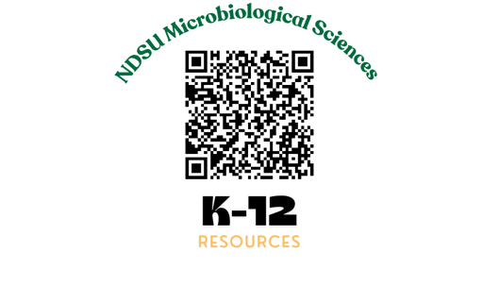
- Students will write a reflection in their science journals about what they learned and how it relates to their everyday lives.

References:
Got this from another teacher? Check out our other resources at: https://www.ndsu.edu/agriculture/academics/academic-units/microbiological-sciences/k-12-teaching-resources

Making the Lesson Plan Culturally Relevant

1. Diverse Examples:
- Include examples of microbes and their roles from various cultures. For instance, discuss how different cultures use fermentation (which involves microbes) to create foods like yogurt, kimchi, sauerkraut, and miso.

2. Local Context:
- Adapt the sampling activity to include areas that are culturally significant or commonly used within the local community. This can involve sampling from local markets, community centers, or specific cultural artifacts.

3. Inclusive Discussion:
- Facilitate discussions about hygiene and health practices that are culturally sensitive and acknowledge different cultural norms and practices around cleanliness and health.

4. Language and Communication:
- Use culturally relevant language and ensure that any scientific terms are explained in a way that is accessible to students from diverse backgrounds. Incorporate multilingual resources if necessary.

5. Guest Speakers and Resources:
- Invite guest speakers from diverse cultural backgrounds who can share their experiences and knowledge about the importance of microbes in their cultures. Utilize multimedia resources that reflect a variety of cultural perspectives.

6. Acknowledge Contributions:
- Highlight contributions of scientists from diverse backgrounds in the field of microbiology. Discuss how different cultures have historically contributed to the understanding and utilization of microbes.

7. Real-Life Applications:
- Discuss real-life applications of microbiology in various cultural contexts, such as traditional medicine, food preservation methods, and environmental conservation practices.
Adapting the Lesson Plan for Different Grade Levels

For Grades K-5:

- Simplify Vocabulary: Use simpler language and fewer scientific terms. Explain concepts like "microbes" as "tiny living things" and "agar plates" as "special jelly for growing tiny things."
- Hands-On Activities: Focus more on the hands-on aspect, such as swabbing surfaces and observing changes. Provide more guidance during the microscope use.
- Shorten and Visualize: Shorten the lesson duration and include more visual aids, such as videos or pictures of microbes.
- Storytelling Approach: Use stories or animations to explain the role of microbes in the environment and hygiene. This helps young students relate to the concepts.
- Guided Worksheets: Provide simpler, more guided worksheets for identification and reflection activities.

For Grades 9-12:

- In-Depth Analysis: Include more detailed information on the types and functions of microbes, such as bacteria, viruses, fungi, and protozoa.
- Advanced Techniques: Introduce more advanced techniques like staining procedures, use of more sophisticated microscopes, and even PCR (Polymerase Chain Reaction) for identifying microbial DNA if resources allow.
- Extended Research Projects: Allow students to design their own experiments, collect data over a longer period, and present their findings in a formal report.
- Critical Thinking: Incorporate discussions on the impact of microbes on health, biotechnology, and environmental science. Encourage debates or presentations on topics such as antibiotic resistance or the use of microbes in industry.
- Cross-Disciplinary Links: Link the lesson to other subjects such as chemistry (chemical processes of microbial growth) and health education (impact on human health).

Worksheet for Grades K-5

Name:______________________
Date:______________________
Microbes All Around Us!

1. What is a microbe?

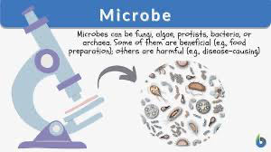
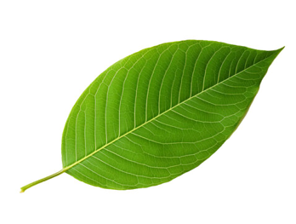
A microbe is a tiny living thing that you can't see with your eyes. Circle the picture that shows a microbe:


2. Draw where you took your sample:

3. What did you see after a few days? Circle what you saw on your plate:

(a) Nothing (b) Spots or dots (c) Big fuzzy blobs

4. Draw what you see under the microscope:

5. Why is it important to wash our hands?

Worksheet for Grades 6-8

Name:______________________
Date:______________________
Microbes All Around Us!

1. What is a microbe?

2. Where did you take your sample?

3. What do you predict will grow on your agar plate?

4. Observe your agar plate after a few days. Describe what you see:

Number of colonies: __________
Colors of colonies: ___________
Shapes of colonies: ___________

5. Use the microscope to observe a sample. Sketch what you see:

6. Identify the microbes using the provided guide (Shape: cocci, bacilli, spirals or Arrangement: staph, strep, singular). What types did you find?

7. Why is it important to understand microbes in our environment?

Worksheet for Grades 9-12

Name:______________________
Date:______________________
Microbes All Around Us!

1. Define the following terms:

- Microbe:
- Agar plate:
- Colony:
- Pathogen:

2. Describe your sampling method. Where did you collect your sample and how?

3. Formulate a hypothesis about what types of microbes you expect to find.

4. After the incubation period, observe and record the characteristics of the microbial growth:

Number of colonies: __________
Morphology (shape, color, texture): __________
Any notable patterns or differences: __________

5. Microscope Observation: Prepare a slide from your sample and observe it under the microscope. Sketch and label your observations.

6.Analyze the significance of your findings. How do these microbes impact their environment and human health?

7. Discuss the importance of hygiene and methods to control harmful microbes.

