**Lesson Plan: Foldscopes! Making the Invisible Visible**

Lesson Plan Date Created: June 2024

Lesson Plan Date Last Edited: June 2024

Lesson Plan Date Implemented:

Lesson Plan Created by: Danielle Condry, PhD (adapted from online resources)

Audience/Grade Level: Middle School (Grades 6-8) – can be shifted to K-5 or 9-12 – see notes at the end.

Topic: Foldscopes! Making the Invisible Visible

Unit: Microscopic World Exploration

**Step 1 Objectives:**

Students will:

- Assemble a foldscope correctly and independently (Apply).

- Identify and describe at least three microscopic organisms observed through the foldscope (Analyze).

- Explain the importance of microscopy in scientific discovery (Understand).

**Step 2 Assessment Plan**:

Direct Assessment:

- Observation of students assembling foldscopes.

- Assessment of student presentations describing microscopic organisms.

Indirect Assessment:

- Written reflections on the importance of microscopy in scientific discovery.

**Step 3 Activities:**

Materials:

- Foldscopes kits (one per student or group)

- Microscopic slides

- Microscopic organism samples (e.g., pond water, onion cells)

- Worksheet for reflections

Preparation of Materials/Timeline:

1. Introduction (15 minutes)

- Discuss the importance of microscopes in scientific discovery.

- Explain the objectives of the lesson.

2. Foldscope Assembly (5-10 minutes)

- Demonstrate how to assemble a foldscope.

- Allow students to assemble their own foldscopes independently.

3. Microscopic Exploration (45 minutes)

- Provide students with prepared slides containing various microscopic organisms.

- Instruct students to observe and identify the organisms through their foldscopes.

- Encourage students to record their observations.

4. Presentation and Discussion (20 minutes)

- Have students present their observations to the class.

- Facilitate a discussion on the diversity of microscopic life and its significance.

5. Reflection (10 minutes)

- Distribute reflection worksheets.

- Ask students to reflect on the importance of microscopy in scientific discovery.

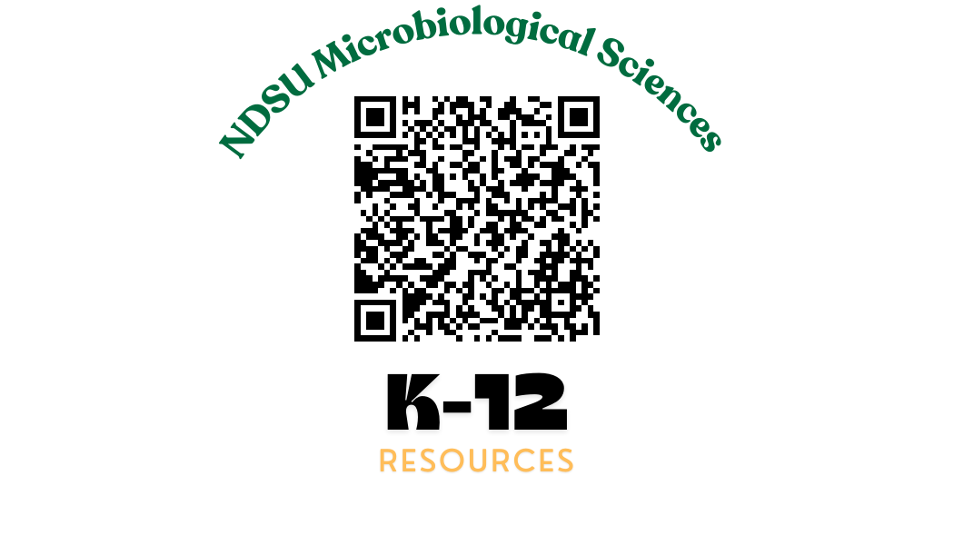**References**:

- Foldscope: <https://www.foldscope.com/>

Got this from another teacher? Check out our other resources at: <https://www.ndsu.edu/agriculture/academics/academic-units/microbiological-sciences/k-12-teaching-resources>

**Ideas for Making the Lesson Plan Culturally Relevant**:

1. Highlight Diverse Contributions: Include stories and contributions from scientists of diverse cultural backgrounds who have made significant advancements in microscopy and related fields. For instance, discuss the work of Dr. Patricia Bath, an African American ophthalmologist and inventor, or Dr. Tu Youyou, a Chinese pharmaceutical chemist and Nobel Prize winner.

2. Connect to Local Ecosystems: Encourage students to collect samples from their local environment, such as nearby ponds, gardens, or school grounds. This not only makes the lesson more relevant to their daily lives but also fosters a connection to their community's natural surroundings.

3. Incorporate Multilingual Resources: Provide resources and materials in multiple languages if you have a diverse student population. This can include translated instructions for assembling the foldscope, as well as multilingual labels for microscopic samples.

4. Celebrate Cultural Practices: Integrate discussions on how different cultures view and utilize microscopic organisms. For instance, explore traditional uses of algae in various cuisines or the role of microorganisms in fermentation processes used in diverse cultural practices.

5. Culturally Inclusive Examples: Use examples and case studies from various cultures when discussing the applications of microscopy. Highlight how different societies have utilized microscopic technology in agriculture, medicine, and environmental science.

6. Invite Community Experts: If possible, invite guest speakers from diverse cultural backgrounds who work in scientific fields. They can share their experiences and emphasize the importance of inclusivity in science.

**Shifting the Lesson Plan for Different Grade Levels:**

**For Grades K-5:**

- Simplify the language and concepts used in the introduction to make it more accessible to younger students.

- Provide more hands-on guidance during the foldscope assembly, possibly through group or teacher-led activities.

- Use larger and more visually appealing samples for microscopic exploration, such as colorful pond water organisms or easily recognizable plant cells.

- Encourage students to draw their observations instead of relying solely on written descriptions.

- Modify the reflection worksheet to include more visual prompts or simple questions.

For Grades 9-12:

- Increase the complexity of the microscopic organisms used for exploration, potentially incorporating advanced specimens or discussing specific cellular structures.

- Provide additional resources or readings on the history and advancements in microscopy for deeper understanding.

- Introduce more sophisticated microscopy techniques beyond foldscopes, such as electron microscopy, and discuss their applications in scientific research.

- Encourage students to explore specific research questions or hypotheses using the foldscopes and guide them in designing experiments accordingly.

- Emphasize critical thinking and analysis in the presentation and discussion phase, encouraging students to evaluate the reliability of their observations and draw meaningful conclusions.

**Worksheet for Grades K-5:**

Microscopic Exploration Worksheet

Name: _______________________

1. Look through your foldscope and describe what you see. Draw a picture of the tiny things you observe.

2. What colors do you see? Circle them.

- Red Yellow Blue Green Orange Purple

3. Pick one thing you saw under the foldscope and write a sentence about it.

4. Draw a picture of yourself using the foldscope.

Worksheet for Grades 6-8:

Microscopic Exploration Worksheet

Name: _______________________

1. Draw a picture and label one organism you observed through the foldscope. Include its shape, color, and any notable features.

2. How did the foldscope help you see things that you couldn't see with your eyes alone?

3. List three new vocabulary words you learned during this activity and their definitions.

4. If you could explore anything else using a foldscope, what would it be and why?

Worksheet for Grades 9-12:

Microscopic Exploration Worksheet

Name: _______________________

1. Choose one microscopic organism you observed. Draw and describe its cellular structure and any specialized features you noticed.

2. Reflect on the limitations of using a foldscope compared to more advanced microscopy techniques. How might these limitations impact scientific research?

3. Discuss the significance of microscopy in modern scientific inquiry. How has microscopy contributed to our understanding of the natural world?

4. Design an experiment using the foldscope to investigate a specific biological question. Outline the steps of your experiment and your expected outcomes.