Lesson Plan: Microbes All Around Us (without microscopes)

Lesson Plan Date Created: 2024-06-10
Lesson Plan Date Last Edited: 2024-06-10
Lesson Plan Date Implemented:
Lesson Plan created by: Danielle Condry, PhD

Audience/Grade Level: Middle School (Grades 6-8) – can be shifted to K-5 or 9-12 – see notes at the end.
Topic: Microbes All Around Us
Unit: Environmental Science
Goal: This lesson plan aims to engage students in hands-on science and promote a deeper understanding of the invisible world of microbes that impacts our daily lives.
Step 1 Objectives (What do I want my audience/students to be able to do after this lesson?):
Students will:
1. Describe the ubiquity of microbes in the environment.
2. Practice environmental sampling methods to collect microbes.
3. Observe the results of microbial growth and make inferences about microbial presence in various environments.
4. Discuss the impact of microbes on health and the environment.

Step 2 Assessment Plan (How will I know my audience/students accomplished the objectives?):

Direct Assessment:
- Students will create and submit a lab report detailing their sampling methods, observations, and conclusions about microbial presence in their chosen environments.
- Participation in group discussions and presentations about their findings.

Indirect Assessment:
- Informal observation during the activities to gauge student engagement and understanding.
- Student self-reflection and feedback forms on what they learned about microbes.

Step 3 Activities (How I will help my audience/students achieve the objectives?):

Materials:
- Sterile swabs
- Petri dishes with agar (pre-prepared)
- Permanent markers
- Parafilm strips to seal plates
- Access to handwashing facilities

Preparation of Materials/Timeline:
- 1 day before: Order/prep Petri dishes with agar. Store plates in the cold room/fridge until the day of use. To prepare agar, weigh 28g of Nutrient Agar powder and add it to 1 liter of water. Heat and stir often until the media reaches a strong, rolling boil. The media should be completely see-through and not cloudy. Let cool for 10-15 minutes (should still be warm). Then, pour the media into the bottom of each plate (the wider half is the lid, the smaller half is the bottom). The agar should be half full in the petri plate ~ 20 ml. 1 Liter should make 40 plates. Immediately place the lid on each poured plate (to avoid environmental air microbes landing on the plate) and let it cool to harden before storing.
- Day of the lesson: Set up stations with materials and instructions.

Activity Steps:

1. Introduction to Microbes (15 minutes)
- Brief presentation on microbes, their ubiquity, and their roles in the environment and health.
- Discuss safety and hygiene protocols when working with microbes.
- Demonstrate how to use sterile swabs and collect samples from different environments (e.g., classroom surfaces, soil, water from a nearby pond).

2. Environmental Sampling (30 minutes)
- Students work in pairs to collect samples, swab them onto agar plates, and label their samples accurately.

3. Incubation Period (2-3 days up to 1 week)
- Store the agar plates in a safe place at room temperature.
- Students make predictions about microbial growth.

4. Observation and Analysis (30 minutes)
- After one week, students observe the microbial growth on their agar plates.
- Record observations, including the type and amount of growth.

5. Group Discussion and Presentation (20 minutes)
- Students present their findings to the class, discussing the differences in microbial growth from different environments.
- Facilitate a discussion on the implications of microbial presence in various environments and the importance of hygiene.

6. Conclusion and Reflection (15 minutes)
- Summarize key points about the ubiquity and impact of microbes.
- Students complete a reflection activity on what they learned and how it applies to real-life scenarios.

References:

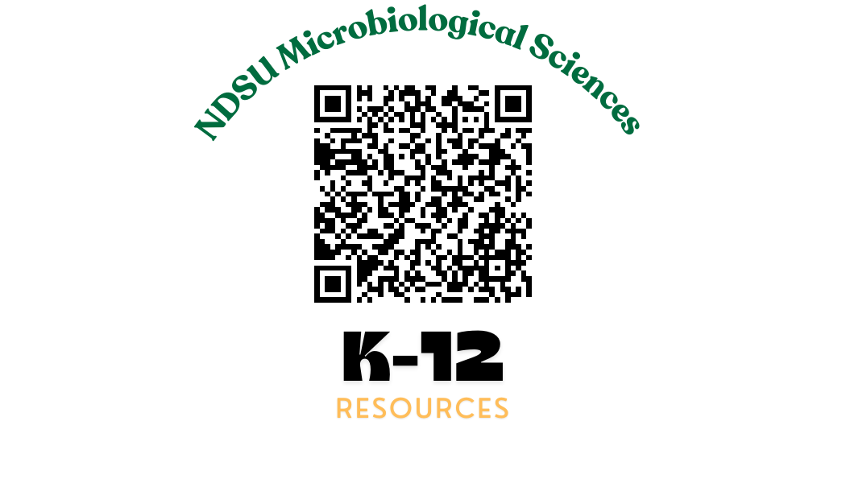
Got this from another teacher? Check out our other resources at: https://www.ndsu.edu/agriculture/academics/academic-units/microbiological-sciences/k-12-teaching-resources

Making the Lesson Plan Culturally Relevant:

To make this lesson plan culturally relevant, consider the following strategies:

1. Incorporate Local Context:
- Include examples and case studies of microbes that are significant to the local environment or culture. For instance, discuss how local water sources, soil types, or agricultural practices influence microbial life.

2. Diverse Perspectives:
- Highlight contributions from scientists of diverse backgrounds in the field of microbiology. Share stories of microbiologists from different cultures and their discoveries.

3. Community Connections:
- Engage with the community by involving local environmental organizations, health departments, or universities. Invite guest speakers to discuss how microbial research impacts the local community.

4. Cultural Practices:
- Explore traditional practices related to fermentation, food preservation, and hygiene. Discuss how different cultures utilize microbes in food production (e.g., yogurt, kimchi, sauerkraut) and their impact on health and nutrition.

5. Language and Accessibility:
- Ensure that all materials are accessible to students from diverse linguistic backgrounds. Provide translations or bilingual resources if necessary.

6. Respect and Inclusion:
- Encourage students to share their cultural experiences and perspectives related to microbes and hygiene.

7. Global Awareness:
- Discuss global health issues related to microbes, such as infectious diseases, antibiotic resistance, and sanitation. Emphasize the interconnectedness of global communities and the importance of collaborative efforts in addressing microbial challenges.
Lesson Plan Adjustments for Different Grade Levels

For younger students, we shifted the focus to engaging their curiosity and providing hands-on, visual experiences. For older students, the emphasis was shifted to developing critical thinking, scientific inquiry skills, and deeper understanding of the subject matter.

Grades K-5 Adjustments:

Objectives:
1. Recognize that microbes are tiny living things found everywhere.
2. Learn simple sampling methods to collect microbes.
3. Observe microbial growth and discuss what microbes might be doing in different places.

Activities:
- Simplified Introduction: Use more visuals and simpler language to explain what microbes are and where they can be found.
- Guided Sampling: Instead of students collecting samples themselves, demonstrate the process and let students observe or assist.
- Observation: Have students observe the growth on agar plates with the teacher’s help and discuss what they see.
- Art and Storytelling: Incorporate drawing activities where students draw what they think microbes look like and write stories or explanations about the "microbe world."
- Group Discussion: Use a show-and-tell format where students share what they observed.

Assessment:
- Use pictures and simple charts to help students explain their findings.
- Conduct a class discussion to share observations and thoughts about microbes.

Grades 9-12 Adjustments:

Objectives:
1. Analyze the ubiquity and diversity of microbes in various environments.
2. Apply advanced sampling methods and techniques for microbial collection.
3. Investigate the implications of microbial presence on health, environment, and industry.

Activities:
- Detailed Introduction: Include more in-depth information on microbial taxonomy, roles in ecosystems, and their impact on human health and industry.
- Advanced Sampling: Teach students more precise and varied sampling methods (e.g., air sampling, water filtration).
- Research Component: Incorporate a research project where students design their own experiments, collect data, and analyze results.
- Data Analysis: Introduce basic statistical methods to analyze the collected data and draw conclusions.
- Presentation: Have students create detailed reports and presentations using digital tools, possibly including microscopy images sourced from online databases.

Materials:
- Advanced lab equipment if available (e.g., pipettes, sterile containers)
- Access to online microbiology resources for supplementary images and information

Assessment:
- Comprehensive lab reports and research papers
- Formal presentations and peer review sessions
- Quizzes or tests on microbial concepts and laboratory techniques

Worksheet for Grades K-5

Name: ________________________
Date: _________________________

Microbe Hunters: Discovering Tiny Life!

1. What are Microbes?

Draw a picture of what you think a microbe looks like. Use your imagination!

2. Collecting Samples: We will be collecting samples from different places. Where did you collect your sample from? Circle one.

- Classroom Desk
- Door Handle
- Water from a Pond
- Soil from Garden
- Other: ________________________

3. Making Predictions: What do you think will happen on your agar plate? Draw or write your prediction.

4. Observations: After one week, look at your agar plate. Draw what you see.

5. Talking About Microbes: Why do you think it's important to know about microbes? Draw or write your answer.

Worksheet for Grades 6-8

Name: ________________________
Date: _________________________

Microbe Hunters: Exploring the Invisible World

1. Introduction to Microbes: What are microbes? Write a short explanation.

2. Environmental Sampling: Where did you collect your sample from? Describe the location and why you chose it.

3. Predictions: What do you think you will observe on your agar plate? Write your prediction and explain why.

4. Observations and Data Collection: After one week, observe your agar plate. Describe what you see. You can include drawings and measurements (e.g., number of colonies, colors, shapes).

5. Analysis: What does your observation tell you about the presence of microbes in your sampled location? Write a brief analysis.

6. Reflection: How do microbes affect our health and environment? Write a short paragraph reflecting on this question.

Worksheet for Grades 9-12

Name: ________________________
Date: _________________________

Microbe Hunters: Investigating Microbial Life

1. Background Knowledge: What are microbes, and what roles do they play in the environment? Write a detailed explanation.

2. Research Design: Describe your sampling method. Include details about the location, tools used, and the procedure followed.

3. Hypothesis: What is your hypothesis regarding the microbial growth you will observe on your agar plate? Explain the rationale behind your hypothesis.

4. Data Collection and Observation: After one week, document your observations. Include detailed descriptions, drawings, and any quantitative data (e.g., number of colonies, types of microbes identified if possible).

5. Data Analysis: Analyze your data. What patterns do you see? How do your observations support or refute your hypothesis?

6. Conclusion: Write a conclusion based on your analysis. What can you infer about the presence and types of microbes in your sampled location?

7. Discussion: Discuss the broader implications of your findings. How do microbes impact our health, environment, and industry? Include references to scientific literature if applicable.

