A Guidebook for Emergency Managers
Developed by Nora Benson, Anna Kempf, and Ashifur Rahman
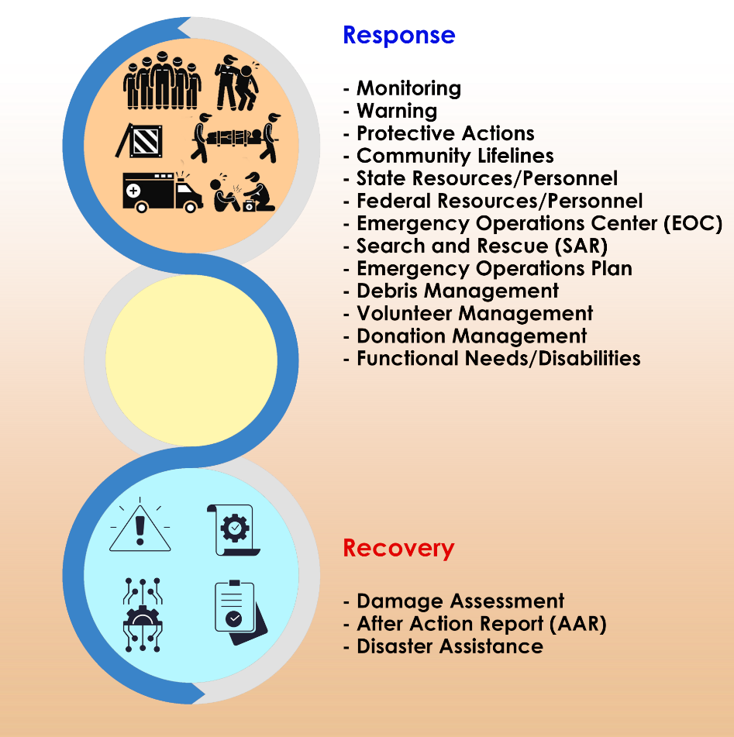

The guidebook is intended to provide a roadmap for emergency managers who are new or infrequently deal with disasters in their jurisdiction. The guidebook is structured with three focused columns that are intersected by common activities that are undertaken in a disaster. These columns are pre-impact (to be undertaken before an event occurs), impact (to address as the event is occurring), and capability expansion (to be undertaken if seeking additional capability in an area). Common language is used in this guidebook, but as terms come up that are commonly reduced to acronyms in the emergency management practitioner community, they are noted. Caution was taken to present enough information to prompt thought or action, without overwhelming the user. Not all information will apply to every community or jurisdiction.

It is not the intent of this guidebook to supplant existing emergency management training or education. This guidebook also does not represent that it covers every nuance of an effective response and recovery; rather, it is intended to be inclusive of major activity areas that emergency managers should be thinking about as they are engaging in these efforts. This guidebook was developed in an editable format so jurisdictions can modify it to meet their specific needs. The items in the capability expansion column are hyperlinked. The appendices include additional information that may be helpful.

This guidebook was created by a student team at North Dakota State University as part of a problem solving collaboration with FEMA Region 8 in May 2024.
RESPONSE
 | PRE-IMPACT | IMPACT | CAPABILITY EXPANSION
MONITORING | - Identify the hazards that affect your area  - Utilize Geospatial Information Systems (GIS) to monitor certain hazards | - Be in contact with partners (e.g., the weather service, fire department, etc.)  regarding updates for ongoing hazard events  - Maintain situational awareness of evolving situations | IS-922.A: Applications of GIS for Emergency Management  IS-103: Geospatial Information Systems Specialist (GISS)
WARNING | - Identify how warning messages are being sent to the community and if it is effective.  - Emergency Alert System (EAS), Wireless Emergency Alert (WEA), Weather Radios – all through Integrated Public Alert and Warning System (IPAWS)  - Social Media  - Sirens  - Local Media  - Law Enforcement  - Pre-script warning messages for common hazards using FEMA templates  Refer to Appendix B | - Create and distribute timely warning messages for your community  Refer to Appendix B | IS-247.B: Integrated Public Alert and Warning System (IPAWS) for Alert Originators  IS-251.A: Integrated Public Alert and Warning System (IPAWS) for Alerting Administrators  IS-42.A: Social Media in Emergency Management  PrepTalks: Dr. Dennis Mileti "Modernizing Public Warning Messaging" | FEMA.gov  Templates | FEMA.gov  Microsoft Word - Hailey's Edits.docx (titanhst.com)  (Emergency notification script samples)
PROTECTIVE ACTIONS | Evacuation  - Identify early warning system for evacuation  - Identify evacuation routes  - Determine transportation arrangements for those who do not have vehicles  - Plan for functional needs/disabled in the community  - Plan messaging regarding evacuation  for those with pets  - Learn about elements of effective evacuations  - Create detailed evacuation plan  - Plan for re-entry processes  Shelter-in-Place (SIP)  - Identify what information should be included in SIP notifications  - What emergency supplies to have  - Designated shelter locations  - Duration of SIP  - Determine follow-up communication and monitoring methods  Shelters  - Determine where shelters should be located and create memorandums of understanding (MOUs) with the management of the facilities for use in a disaster  - Determine how to staff and manage shelters  - Identify how volunteers will be managed  - Develop partnerships with non-governmental organizations (NGOs) and private sector entities  - Determine supply chain coordination  - Conduct periodic shelter drills  - Create system for real-time updates regarding sheltering information  - Determine where resources will be coming from  - Facilities  - Food  - Maintenance | Evacuation  - Communicate evacuation routes  - Coordinate with local/state department of transportation partners  - Ensure preparation of other transportation methods for those without vehicles  Shelter-in-Place (SIP)  - Ensure time-sensitive notifications are being sent out  - Work with partners to determine when threat is abated  Shelters  - Be in contact with supply chain partners to ensure shelters can be properly resourced  - Prepare those who will be staffing the shelters with their duties  - Utilize system for providing updates regarding shelter information for public  - Provide shelters with a way to communicate with key stakeholders and one another | Evacuation | Ready.gov  Planning Considerations: Evacuation and Shelter-in-Place - Guidance for State, Local, Tribal and Territorial Partners (fema.gov)  IS-10.A: Animals in Disasters: Awareness and Preparedness  IS-406: Operating a Shelter  Disaster Shelters | Find Shelters | American Red Cross  Homeless Shelters | The Salvation Army USA
COMMUNITY LIFELINES | - Identify the community lifelines in your area (places that offer support to the community in which they rely on)  - Non-profits (churches, food banks)  - Schools (public/private/  charter)  - First Responders (fire, EMS, police)  - Medical Services (hospitals, clinics, pharmacies)  - Grocery stores  - Retail stores  - Public works  - Private utilities  - Create a resource list that includes the contact information of essential partners and lifelines in your community  Refer to Appendix C | - Gather necessary partners  - Ensure partners do not have any immediate emergency needs  - Maintain open communication lines | IS-2901: Introduction to Community Lifelines  IS-288.A: The Role of Voluntary Organizations in Emergency Management  Emergency Support Function Annexes | fema.gov  Community Lifelines | FEMA.gov
STATE RESOURCES/ PERSONNEL | Identify/Build Relationships with State Personnel  - State Emergency Management  - State FEMA Integration Team (FIT) Lead  - National Guard liaison | - Maintain contact with State regarding ongoing situation  - Work with State partners for additional resources | Colorado  Colorado State and Local Level Referrals | FEMA.gov  Montana  Montana State and Local Level Referrals | FEMA.gov  North Dakota  North Dakota State and Local Level Referrals | FEMA.gov  South Dakota  South Dakota State and Local Level Referrals | FEMA.gov  Utah  Utah State and Local Level Referrals | FEMA.gov  Wyoming  Wyoming State and Local Level Referrals | FEMA.gov  IS-242.C: Effective Communication
FEDERAL RESOURCES/ PERSONNEL | - Identify/Build Relationships with Federal Personnel  - Intergovernmental Affairs  - External Affairs  - Determine where FEMA engagement with local emergency management will occur  - Joint field office  - Emergency Operations Center (EOC)  - Determine what federal resources may be needed in a disaster | - State will maintain contact with Federal partners regarding ongoing situation  - After a declaration, work with State and Federal partners to acquire additional resources to manage the event | FEMA Region 8 | fema.gov
EMERGENCY OPERATIONS CENTER (EOC) | - Establish the location of a primary and secondary EOC:  - Away from potential hazards  - Public facility  - Office building  - Event center  - Temporary structure  - Establish preliminary critical members of EOC:  - Local Emergency Manager  - Public Information Officer (PIO)  - Communications Coordinator  - IT/Technical Support  - Security/Law Enforcement  - Fire/EMS  - Facilities Manager  - County Administrator  - Familiarize yourself with EOC roles and responsibilities | - Prepare EOC location for activation  - Call in key EOC members for activation  - Ensure EOC members know their roles and responsibilities | FEMA EOC Quick-Reference-Guide Virtual Considerations  IS-29.A: Public Information Officer Awareness  IS-2200: Basic Emergency Operations Center Functions  IS-100.C: Introduction to the Incident Command System  IS-200.C: Basic Incident Command System for Initial Response
SEARCH AND RESCUE (SAR) | - Determine the primary organization who will be responsible for SAR  - Fire Department  - Volunteer Fire Department  - Emergency Medical Services  - Community Emergency Response Teams (CERTs)  - Urban Search and Rescue (USAR) Task Forces | - Ensure SAR teams have situational awareness of where to search and additional factors about the population and additional hazards in the area  - Maintain a line of communication with SAR Team Leader | SEARCH AND RESCUE MANUAL (humanitarianlibrary.org)  National Urban Search & Rescue (US&R) Response System | RESCUE FIELD OPERATIONS GUIDE  IS-317.A: Introduction to Community Emergency Response Team (CERTs)
EMERGENCY OPERATIONS PLAN (EOP) | - Develop an all-hazard Emergency Operations Plan (EOP)  - Conduct a hazard and vulnerability assessment (HVA)  - Ensure planning effort includes community partners  - Train and exercise the individuals/agencies with roles and responsibilities in the plan  - Revise plan post-exercise as needed  - Review and update the plan every few years | - Activate key components of the emergency operations plan | Developing and Maintaining Emergency Operations Plans Comprehensive Preparedness Guide (fema.gov)
DEBRIS MANAGEMENT | - Identify the debris management team  - Identify methods of debris collection  - Identify potential temporary debris collection sites  - Identify a collection site for recyclable debris  - Consider issues involved with private property debris removal/entry onto private property  - Consider what debris could be produced from known local hazards  - Create information to be distributed regarding health and safety tips for removing debris | - Activate and mobilize the debris management team  - Consider which key transportation corridors and/or emergency routes need to be cleared first  - Identify location for temporary debris removal  - Ensure information is distributed regarding locations for toxic or hazardous debris | IS-632.A: Introduction to Debris Operations  IS-633: Debris Management Plan Development  Planning for Natural Disaster Debris (epa.gov)
VOLUNTEER MANAGEMENT | - Identify volunteer management coordinator  - Identify sources for volunteers  - Identify stress management resources and protocols for volunteers  - Create a volunteer documentation process  - Roles and responsibilities  of volunteers  - Training records  - Volunteers’ hours  and activities  - Emergency contact list  - Establish Volunteer Referral Center (VRC)  - Location  - Staffing  - Resource support | - Match volunteers to job assignments based on their strengths and/or expertise  - Conduct just-in-time training for volunteers  - Ensure check-in system is tracking volunteer assignments and hours  - Have stress management resources ready for volunteers and other staffers | IS-244.B: Developing and Managing Volunteers  Managing Spontaneous Volunteers in Times of Disaster  Volunteer and Donations Management Support Annex (fema.gov)
DONATION MANAGEMENT | - Identify physical donation storage location  - Warehouse  - Schools  - Gymnasium  - Create system for management of inventory  - Consider approaches for management of the site  - Consider approaches for distribution of donations | - Perform needs assessment prior to request for donations  - Ensure physical location is ready for influx of donations  - Have appropriate staffing for sorting, organizing, and recording of donations  - Ensure system is in place for online donations | Volunteer and Donations Management Support Annex (fema.gov)
FUNCTIONAL NEEDS/ DISABILITIES | - Identify and work with partners working with residents with functional needs or disabilities to inform response efforts  - Consider the ways in which consideration of  residents with functional needs or disabilities affects response structures, processes, and decisions (e.g., warning, evacuation, other protective actions, shelter criteria, service animal accommodations, SAR etc.) | - Partner with community organizations that work with residents with  functional needs or disabilities to meet  needs effectively | People with Disabilities | Ready.gov  People with Disabilities | disasterassistance.go

RECOVERY
 | PRE-IMPACT | IMPACT | CAPABILITY EXPANSION
DAMAGE ASSESSMENT | - Establish “First-In Team”  - Public works  - Fire  - Police  - EMS  - CERT  - Establish damage assessment response team  - Engineers  - Building inspectors  - Firefighters  - Voluntary Organizations Active in Disasters (VOADs) | - Conduct Preliminary Damage Assessment (PDA) with damage assessment team  - Report findings to State/Federal partners | IS-559: Local Damage Assessment  Preliminary Damage Assessment Guide (fema.gov)
AFTER ACTION REPORT (AAR) | - Establish processes to collect/maintain information that can inform the after action review  - Create a distribution list for AAR distribution | - Work with partners to gather information from incident reports, communications records, observations, etc.  - Conduct root cause analysis to identify root causes  - Identify strengths, weaknesses, and areas for improvement  - Write AAR and communicate findings and recommendations to partners and relevant stakeholders  - Develop training and exercises based off findings from report  - Revise EOP as needed | After-Action Reports: Capturing Lessons Learned and Identifying Areas for Improvement
DISASTER ASSISTANCE | - Create a pre-event list of possible needs to expediate needs assessment in a disaster  - Gather data about the value of government and community property and assets | - Assess and create list of immediate needs  - Create list of damaged items and their value  - Communicate with Disaster Recovery Centers (DRCs)  - Communicate with FEMA helpline  - Conduct assessment with FEMA inspector  - Supply disaster assistance information  to community and stakeholders | Individuals and Households Program | FEMA.gov  IS-403: Introduction to Individual Assistance (IA)  How to apply for disaster assistance  What to Expect When You Apply Online | disasterassistance.gov  DisasterAssistance.gov | Location Search  Disaster Recovery Center (DRC) Locator | fema.gov  Achieving Equitable Recovery: A Post-Disaster Guide for Local Officials and Leaders (fema.gov)
FINANCIAL AID | - Determine what types of aid would benefit those in your community  - Small Business Administration (SBA) Loans  - Government Assistance (FEMA)  - Nonprofit Assistance (American Red Cross, Salvation Army, local NGOs)  - Tax Relief  - Determine financial aid partners at state/federal levels  - Department of Housing and Urban Development (HUD)  - Voluntary Organizations Active in Disasters (VOADs)  - Department of Agriculture (USDA) | - Ensure stakeholders have access to financial aid information relevant to their sector  - Communicate with State/Federal partners on financial aid needs of the community | Disaster Financial Management Guide (fema.gov)  Disaster Recovery Cost Documentation (gfoa.org)  Financial Planning for Natural Disasters: A Workbook for Local Governments and Regions

APPENDIX A: General Links
- FEMA Independent Study Courses
  - https://training.fema.gov/is/crslist.aspx?lang=en&all=true
- Mission Areas and Core Capabilities:
  - https://www.fema.gov/emergency-managers/national-preparedness/mission-core-capabilities
- National Disaster Recovery Framework:
  - https://www.fema.gov/sites/default/files/2020-06/national_disaster_recovery_framework_2nd.pdf
- National Mitigation Framework:
  - https://www.fema.gov/sites/default/files/2020-04/National_Mitigation_Framework2nd_june2016.pdf
- National Preparedness Goal:
  - https://www.fema.gov/sites/default/files/2020-06/national_preparedness_goal_2nd_edition.pdf
- National Response Framework:
  - https://www.fema.gov/sites/default/files/2020-04/NRF_FINALApproved_2011028.pdf
- National Incident Management System:
  - https://www.fema.gov/emergency-managers/nims
- Practitioners:
  - https://www.fema.gov/emergency-managers/practitioners
- Recovery Resources:
  - https://www.fema.gov/emergency-managers/practitioners/recovery-resources

APPENDIX B: Warning Message Templates
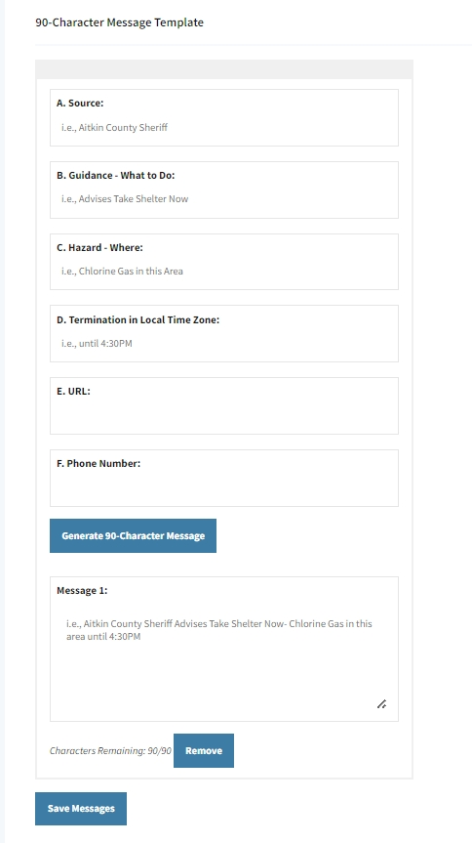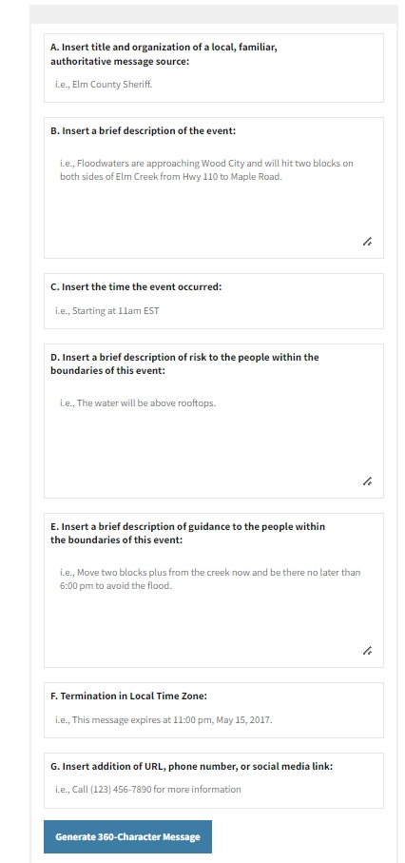

Appendix C: Community Contact Information Template

Name of Business/Org/  Community  Partner | Primary  Point- of- Contact Name & Position | Primary  Email  Office phone  Office cell  Personal cell | Secondary Point- of- Contact Name & Position | Secondary  Email  Office phone  Office cell  Personal cell | Other Pertinent Information  (e.g., home address, site location, etc.)
Appendix D: FEMA IS Course Descriptions
MONITORING
IS-922.A: Applications of GIS for Emergency Management | The goal of this course is to explore how GIS technology can support the emergency management community. Topics addressed in this course include: GIS fundamentals and history; how GIS is used in emergency management and tools available to enhance GIS usefulness
IS-103: Geospatial Information Systems Specialist (GISS) | This course prepares students to successfully assume the role and responsibilities of a Geospatial Information Systems (GIS) Specialist (GISS) during a disaster situation. As they complete this course, students will learn how to use their GIS skills to support other members of a Joint Field Office (JFO) disaster response and recovery team and successfully meet the responsibilities assigned to them. Students will also learn what types of products need to be produced and what procedures must be followed to ensure that products are produced correctly and in a timely manner.
WARNING
IS-247.B: Integrated Public Alert and Warning System (IPAWS) for Alert Originators | The goal of this course is to provide authorized public safety officials with increased awareness of the benefits of using Integrated Public Alert and Warning System (IPAWS) for effective alerts and warnings; skill to draft more appropriate, effective, and accessible alert and warning messages; the importance of training, testing, and exercising with IPAWS; and best practices in the effective use of IPAWS to reach members of the public.
IS-251.A: Integrated Public Alert and Warning System (IPAWS) for Alerting Administrators | This course provides information on Integrated Public Alert and Warning Systems (IPAWS) for Alerting Administrators. The goal of this course is to provide guidance to those becoming authorized Alerting Administrators for IPAWS.
IS-42.A: Social Media in Emergency Management | The purpose of this course is to provide the participants with best practices including tools, techniques, and a basic roadmap to build capabilities in the use of social media technologies in their own emergency management organizations (State, local, Tribal) in order to further their emergency response missions.
PROTECTIVE ACTIONS (Evacuation, Shelter-in-Place, and Shelters)
IS-406: Operating a Shelter | This 5-hour independent study course will support state, local, tribal, and territorial (SLTT) governments, as well as community and faith-based, non-profit, and private sector partners to increase readiness for shelter site management and congregate shelter operations and to provide best practices and common methodology.
IS-10.A: Animals in Disasters: Awareness and Preparedness | This course is intended to help animal owners, care providers, and industries to understand incident management.
COMMUNITY LIFELINES
IS-2901: Introduction to Community Lifelines | IS-2901, Introduction to Community Lifelines, introduces the Community Lifelines construct, an outcome-driven response structure used to achieve incident stabilization. This course provides an overview of the seven (7) Community Lifelines, including how they promote the importance of situational awareness, prioritization of response efforts, and decision-making processes during a disaster response to work toward incident stabilization.
IS-288.A: The Role of Voluntary Organizations in Emergency Management | This independent study course provides a basic understanding of the history, roles, and services of disaster relief voluntary agencies in providing disaster assistance. It is appropriate for both the general public and those involved in emergency management operations.
STATE/FEDERAL RESOURCES & PERSONNEL
IS-242.C: Effective Communication | This course is designed to improve your communication skills. It addresses: Basic communication skills; How to communicate in an emergency: How to identify community-specific communication issues; Using technology as a communication tool; Effective oral communication; How to prepare an oral presentation
EMERGENCY OPERATIONS CENTER (EOC)
IS-29.A: Public Information Officer Awareness | The Public Information Officer Awareness Course (IS0029) is designed to familiarize participants with the concepts underlying the PIO role. This course can provide a basic understanding of the PIO function for those new to the position. Additionally, it can provide those in executive level roles the necessary knowledge of PIO roles and responsibilities during an emergency.
IS-2200: Basic Emergency Operations Center Functions | The Basic Emergency Operations Center Functions course is designed to introduce the role, design, and function of the Emergency Operations Center (EOC) and the supportive relationship as a NIMS Command and Coordination component of the Multiagency Coordination System.
IS-100.C: Introduction to the Incident Command System, ICS 100 | ICS 100, Introduction to the Incident Command System, introduces the Incident Command System (ICS) and provides the foundation for higher level ICS training. This course describes the history, features and principles, and organizational structure of the Incident Command System. It also explains the relationship between ICS and the National Incident Management System (NIMS).
IS-200.C: Basic Incident Command System for Initial Response, ICS-200 | IS200, Basic Incident Command System for Initial Response, reviews the Incident Command System (ICS), provides the context for ICS within initial response, and supports higher level ICS training. This course provides training on, and resources for, personnel who are likely to assume a supervisory position within ICS.
SEARCH AND RESCUE (SAR)
IS-317.A: Introduction to Community Emergency Response Team (CERTs) | This Independent Study (IS) course is an introduction to the Community Emergency Response Team (CERT) program for those interested in learning about the CERT program for their own knowledge or as a pre-requisite for completing the CERT Basic classroom training that may be available in your community.
DEBRIS MANAGEMENT
IS-632.A: Introduction to Debris Operations | This course covers basic information about debris operations under FEMA’s Public Assistance Program. The goal for this course is to familiarize the student with general debris removal operations and identify critical debris operations issues.
IS-633: Debris Management Plan Development | This course familiarizes students with the concepts of a debris management plan and the process and components involved in developing a comprehensive debris management plan.
VOLUNTEER MANAGEMENT
IS-244.B: Developing and Managing Volunteers | The goal of this course is to strengthen abilities to prepare for and manage volunteers before, during, and after a severe emergency or major disaster.
DAMAGE ASSESSMENT
IS-559: Local Damage Assessment | This course provides information and resources that will enable participants to plan an effective damage assessment program and conduct rapid and effective damage assessments in order to save lives, protect property and the environment, and begin the process of recovery and mitigation.
DISASTER ASSISTANCE
IS-403: Introduction to Individual Assistance (IA) | This course provides FEMA personnel and partners with a basic knowledge of the Individual Assistance (IA) Program and activities that help individuals and households recover following a disaster. The learner must achieve a minimum passing score of 75% on final knowledge assessments or demonstrate mastery on performance assessments or research assignments to earn the IACET CEU.

