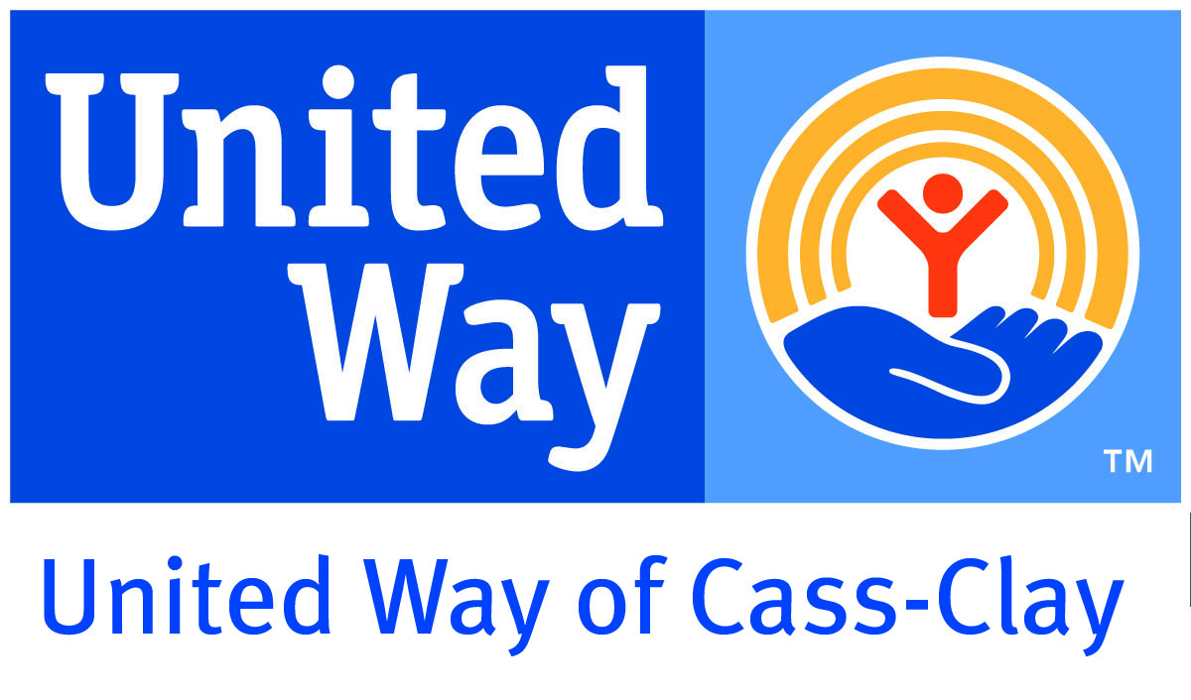

You Are Needed
Today’s Date: April 23, 2012
Publication Date: April 29, 2012

Tree Planting Volunteers
River Keepers is seeking individuals, families, older adults, youth 4+ and small/large groups to volunteer at the Reforest the Red event. The duties for the event include digging holes, planting trees, and mulching. The time and location of the event is Tuesday, May 22nd at Lindenwood Park, 17015th St. S. in Fargo. Volunteers can come anytime between 4:00 pm – 7:00 p.m.

Parrot Shelter Volunteer
Center for Avian Adoption, Rescue, and Education (C.A.A.R.E.) is seeking individuals 16+, families, older adults, and small groups to volunteer at the shelter. Responsibilities are changing food, water, papers, general shelter cleaning assistance for parrot shelter, assist in avian supply warehouse, and socialize/play with parrots. The shelter location is 2202 2nd Ave. E, West Fargo. Volunteers may set their own days and/or hours.

Kitchen Volunteers
Hope Village, an inter-faith effort led by Lutheran Disaster Response, Minot, ND is in need of volunteers to serve meals and help in the dining area assisting the team of cooks. We need 2-3 people for each shift for breakfast and dinner. The shifts available are 6:30 a.m. – 8:30 a.m. and 5:30 p.m – 7:30 p.m., Monday through Friday. We ask that volunteers be at least 16+ because we will be serving hot food. Volunteers need to wear a hat and report to the dining tent at the far east side of the church parking lot. The location is Our Savior Lutheran Church, 3705 11th St. SW in Minot.

Customer Service Assistant
Lake Agassiz Habitat for Humanity ReStore is in need of volunteers to provide customer service to ReStore customers at the front counter. Duties include: cashiering, answering phones, greeting, and answering questions. Other duties may also include pricing, cleaning, and organizational projects throughout the store. Individuals, older adults, and youth 18+ are needed for shifts (4 hours minimum per week) at ReStore from 10 a.m.- 6 p.m. weekdays (except Weds/Thurs from 10 a.m. – 2 p.m.) and 10 a.m. – 4 p.m. on Saturdays. ReStore is located at 210 N. 11 St. in Moorhead, MN.

Donations Pick-Up Assistant
Lake Agassiz Habitat for Humanity ReStore is in need of volunteers. Duties are to assist Donations Coordinator on weekly donation pick-ups in Fargo-Moorhead community. This would include loading and unloading of donations, navigation of route, and driving of ReStore truck if eligible. Knowledge of Fargo-Moorhead area and a positive attitude is highly recommended. Donation pick-ups currently take place on Thursdays from 8 a.m. – 5 p.m. Minimum of a 4 hour shift commitment is requested. The truck leaves from Restore, located at 210 N 11th St., Moorhead, MN.

Warehouse/Deconstruction Volunteer
Lake Agassiz Habitat for Humanity ReStore is seeking individuals, small groups, and youth 18+ to volunteer. Volunteers will assist ReStore staff at processing materials donated to the ReStore, which include unloading, cleaning, and testing. Volunteers will also assist with deconstruction projects as they come up. Deconstruction is the process by which Habitat ReStore removes fixtures, cabinets, and other usable home improvement materials from a property that will either be renovated or demolished. Materials are then sold in the ReStore to benefit Habitat for Humanity. Crew members would help to deconstruct the property, which requires the ability to lift heavy objects, basic knowledge of tools, and interest in labor-intensive fun. Warehouse volunteers are needed weekly for a 2 – 4 hour shift anytime from 10 – 6 Monday through Friday, or 10 – 4 on Saturdays. Deconstruction projects will take place during this time frame as well as when they are scheduled. Volunteers will work at Habitat Restore located at 210 11th St. N, Moorhead, MN.

Volunteer for Person with ALS
The ALS Association, MN/ND/SD Chapter is in need of individuals age 18+ to volunteer. Responsibilities for this position include playing an important role of reducing stress and increasing the quality of life for a person with ALS, commonly known as Lou Gehrig’s Disease, by helping with household chores such as: cleaning, errands, gardening, light maintenance, meals, pet care, scrap booking, snow removal, yard work, and/or visiting. Volunteers are needed Monday through Thursday any time between 5 p.m. – 9 p.m., 2 – 4 times per month, 3 – 4 hours. Location is 20 miles east of Moorhead.

Midwest Kid Fest
Fargo Parks District is looking for volunteers to fill various positions for Midwest Kid Fest. Opportunities available are Information: answer questions, direct people, and pass out programs (only 1 person needed per shift), Belly Bumpers: supervise and play with kids using the bell bumpers in the Busy Bodies area (4 needed per shift), and Life Size Games: supervise and play with kids in the Life Size Games area which includes Scrabble, Tic Tac Toe, Kerplunk, Character Wheel, Cherry Tree, and Checkers (8 needed per shift). Individuals, families, large groups (up to 30 people), small groups (2-6 people), older adults, and youth age 14+. Volunteers are needed on June 15th with shifts available from 10:30 – 7 p.m: 10:30 – 2p.m., 1:30 – 4:30 p.m., or 4 – 7:30 p.m. at Island Park; 616 1st Ave. S, Fargo.

Medical Escort
Rosewood on Broadway is seeking volunteers to escort residents to medical appointments. Responsibilities will be to escort the resident to medical appointments. The driver gets the residents into the vehicle and drives to the appointment. When they get to the appointment the driver gets resident into the building and the medical escort gets them to where they need to be for the appointment. The medical escort waits in the waiting room until resident is done, then they take the resident back to where they were dropped off and will call for the ride to come back and pick them up. The driver then gets the resident back into the vehicle and the medical escort rides back to Rosewood. When they arrive at Rosewood, the drive gets the resident out of the vehicle and back into Rosewood. It is an on call basis and no obligation. You can say yes or no when you are called. Individuals age 55+ and youth age 18+ are encouraged to consider this opportunity.

Fargo Marathon Volunteers
HERO (Healthcare Equipment Recycling Organization) is looking for traffic control volunteers to help at the Fargo Marathon. Families, groups and individuals over 16 are welcome to volunteer. Shifts are available from the early morning to the late afternoon on May 19th. They will donate $4 to HERO for each hour you volunteer. If we have over 50 volunteers, we will receive an extra $500.

Spring Project Community Connect Volunteers
FM Homeless Coalition is seeking individuals and small groups to fill volunteer positions for the Spring Project Community Connect event. There are a variety of volunteer positions available such as registration, guides, and taking appointments. Volunteers are needed Wednesday, April 25th from 8am to 4pm.

Walk to End Alzheimer’s Volunteers
Alzheimer’s Association is seeking volunteers to fill various positions for the Walk to End Alzheimer’s event. Ongoing volunteer positions include Team Captain, office help (mailings), distribution of flyers, and miscellaneous jobs that take as little as 1 hour. Day of Event positions include walker, registration, advocacy, refreshments, parking, 5k finish line, or entertainment. Individuals, families, and small/large groups are welcome to volunteer for this event on Saturday, September 15th at Rendezvous Park.

Senior Companion
Lutheran Social Services of North Dakota, Minot, ND - is looking for Senior Companions. This opportunity is to provide regularly scheduled visits to older adults who need some assistance to maintain their highest degree of independence. Adults age 55+ are encouraged to consider this opportunity. Volunteers are given a small tax-free stipend for hours volunteered.

Foster Grandparent
Tri-Valley Opportunity Council needs adults age 55+ to volunteer their time to work with children ages birth-young adult in supervised nonprofit settings such as schools, day cares, juvenile centers, and other nonprofits. Time asked is 15-40 hours weekly with stipend, holiday, vacation, sick leave, and other benefits.

Thrift Store Retail Volunteer
Heartland Industries, Second Time Around Thrift Store is seeking individuals to volunteer. Duties will include working the cash register, customer service, accepting donations, and various other tasks. Must be 18 years of age or older but would be a great place to get customer service experience! Volunteers are needed Monday-Friday from 10am to 6pm. Training is provided.

Cleaning and Animal Care
Hightail Ranch and Rescue needs volunteers to assist with cleaning and animal care. Volunteers are responsible for cleaning stalls, sweeping barns, feeding and grooming horses, grounds keepings, and many more activities needing to be done. Individuals, families, or groups are all welcome to volunteer. Minimum age is 13 and hours are flexible.

Heart Warmer
Ronald McDonald House Charities needs ‘Heart Warmer’ volunteers once a week (M-F), for two hours between 9am and 5pm to assist guests and guest staff.

Retail Specialist
HERO is looking for individuals to assist customers and design displays of HERO product (wound care, personal hygiene, mobility items, etc.). Volunteer hours vary and HERO is open Monday-Friday 9am-5pm.

Food Distribution and /or Food Order
Dorothy Day Food Pantry is in need of volunteers to help clients with picking up food, stocking shelves, unloading food orders, and shelving the food orders. They are in need Monday-Thursday 11am-4pm and 6-8:30pm. Volunteers should be age 10 or older.

Big Brothers
Big Brothers Big Sisters is looking for male volunteers. Volunteers are asked to make a one year commitment and meet with a child every other week to participate in a variety of activities.

Meal Delivery Volunteers
Valley Senior Services is in need of volunteers to assist with Meals on Wheels Delivery in West Fargo. Volunteers deliver the meals to homebound elderly in our community. Meals are delivered for the noon meal M-F out of the West Fargo Highrise. It is about an hour time commitment each week.

